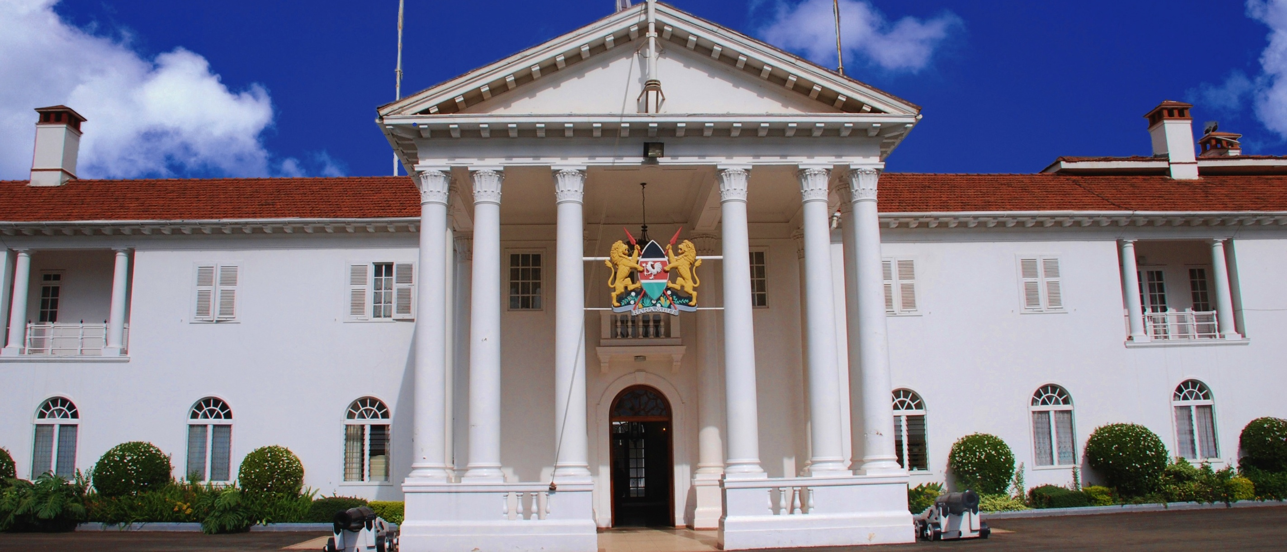

THE PROPOSED STRUCTURE OF THE PRESIDENCY

**THE PRESIDENCY**

**BACKGROUND**

**The Structure of Government**

The structure of the government consists of eighteen ministries and 25 State Departments. The structure is designed to reflect the commitments made by the new government in the Jubilee Manifesto. The manifesto identifies what the Jubilee government envisages would be a frame work that facilitates the identified drivers of the economy in the short and medium term, and seeks to address emerging issues both in the light of the new constitutional dispensation, and, the commitments made in the Jubilee manifesto**.**

**SUMMARY OF STATE DEPARTMENTS**

**The Presidency:**

The Presidency is comprised of the Office of the President and the Office of the Deputy President. In structuring the Presidency, the President has created the Executive office of the President, and, the Executive office of the Deputy President to include and enhance the functions normally done by statehouse and to take over some of the functions hitherto undertaken by the abolished offices of the former Prime Minister and Vice President.

Further the president has in his new structure of the national executive, two ministries to operate out of the Presidency.

1. **Interior and Coordination of National Government**

This is one of two Ministries housed within the Presidency. It is a successor to the former Ministries of Internal Security, Immigration and Home Affairs.

The Ministry’s core function is to keep Kenya safe and secure and to coordinate national government functions.

This Ministry will focus on two broad areas.

* 1. Interior

Interior functions including internal security covering Police, Immigration, Prisons and Correctional services.

* 1. National Government Coordination.

This will ensure effective coordination of National Government functions and services at the county and sub-county levels.

1. **Devolution and Planning**

This newly structured Ministry is the second of two Ministries in the Presidency. It encompasses four large areas of focus that are critical to the Constitutional mandate and policy priorities of the Administration hence placement at the Presidency.

The areas of focus are categorised in three broad spheres.

* 1. Devolution:

Covers devolution, intergovernmental relations and capacity building at the Counties.

* 1. Planning

Covers the functions of the former Ministry of planning that includes national development planning and economic policy management

* 1. Office of Management and Budget.

The office will develop and maintain effective government through budget prioritization and policy direction. It will also be reviewing organizational structure and management procedures in the Executive branch. This unit will deal with human resource management and public sector reform to ensure that intended results are achieved.

* 1. Coordination of targeted Policy priority areas and Initiatives.

These are large policy areas that are key to the Administration and have constitutional imperatives:

* Gender policy and mainstreaming,
* Youth policy and mainstreaming,
* Special interest groups (marginalised; disabled) policies,
* Special areas including arid and pastoralists lands,
* Special programmes and initiatives, and
* National cohesion and integration

Other ministries within the revised structure of government are:

1. **Foreign Affairs**

The Ministry of Foreign Affairs will be tasked with the responsibility of steering Kenya’s foreign policy which will specifically focus on economic diplomacy. This ministry will manage Kenya’s relations with the rest of the world, facilitate the participation of the country in the development and signing of international treaties, conventions and accords, and will coordinate the Kenyan diaspora participation in the economy.

The ministry of foreign affairs will be the single point of contact for the governments foreign engagements with other governments as is the international best practice.

1. **Defence**

This Ministry is charged with the responsibility for development of a modern and effective National Defence policy and plans that will ensure the protection of national Boundaries that are secure from external aggression.

This is the home Ministry for the men and women who constantly put their lives on the line for the security and safety of our people. The Ministry also supports civilian authorities in constitutionally mandated instances

1. **Education, Science & Technology**

This Ministry is a successor to the former Ministries of Education and that of Higher Education, Science & technology.

The Ministry will encompass two State Departments to be managed by one Cabinet Secretary and two Principal Secretaries. The departments are:

* 1. **State Department of Education**

This department will be charged with developing and managing policies and programs on education. A core function is the realization of an educated and professionally well-adjusted workforce for a modern nation.

* 1. **State Department of Science & Technology**

This department will be charged with amongst other functions, policy formulation on Science & Technology. Further, it will be charged with the coordination, inventory & dissemination of scientific and technological research.

1. **The National Treasury**

The stability of the countrys economy for sustainable development is anchored on the pillar of a stable macroeconomic framework. The National treasury will therefore be responsible for developing and managing the macroeconomic policies of the country. This ministry will also be responsible for supervision and monitoring of the constitutional, legal and responsible management of the economy and public financial operations.

The National Treasury will also be responsible for providing oversight of all financial institutions including Cooperatives and Saccos dealing with financial functions.

1. **Health**

This Ministry will be responsible for the development of policies aimed at the provision of high quality and affordable health care for the Kenyan people. It will also be charged with amongst other functions the development of a well-trained and motivated workforce of health professionals, the ability to adequately respond to any public health related issues & emergencies and will have the added focus on preventive healthcare and the responsibility of encouraging private sector investment in the sector.

1. **Transport & Infrastructure**

This Ministry is a successor to the Ministries of Transport and Roads.

It has two State Departments: Transport Services and Infrastructure.

A key task of this Ministry is to position Kenya as the logistics hub of the region by creating a modern and efficient transport system for goods and services within the Counties and also with other countries in the region.

Building on the achievements of the immediate former administration, this Ministry will have an added focus on rail, water and air infrastructure and services.

1. **Environment, Water & Natural Resources**

This Ministry is the successor to three Ministries under the previous Administration: Ministry of Water, Ministry of Wildlife and Forestry, and Ministry of Environment & Mineral Resources. However, it does not have responsibility over Mining and Irrigations as the two functions are now under separate Ministries.

This Ministry will be responsible for policies and programmes aimed at improving, maintaining, protecting, conserving and managing the richness of Kenya’s natural resources including water, forestry, wildlife and environment. In addition, it will tasked with the responsibility of ensuring that Kenyans have good access to clean, safe, adequate and reliable water supply.

1. **Land, Housing & Urban Development**

This is a successor to three Ministries of Lands, Housing and Public Works.

This Ministry is tasked with addressing the perennial land question and to close that debate in a just and fair manner acceptable to Kenyans. It will amongst other functions plan for new urban settlements in coordination with County Governments. It will also be responsible for policy on provision of affordable and adequate housing, as well as policies on land consolidation.

1. **Information, Communication & Technology (ICT)**

The free access of information and constant communication of the government with its citizenry is key pillar of good governance. On the other hand, Information, Communication Technology (ICT) is recognised as one of the key contributors of economic growth. This ministry wil therefore play a key role in driving the economy while at the same time ensuring open and good governance.

This ministry will be responsible for policy formulation for the telecommunication, broadcasting and postal sectors. The ministry will also provide consulting services and market survellance for the rest of government on ICT and ICT equipment and infrastructure.

1. **Sports, Culture and the Arts**

As the cradle of mankind, Kenya has an amazingly rich national and cultural heritage. It is also rich in creative arts and sports talent that needs to be tapped and nurtured to create a rich and vibrant industry for development of our youth and economy. It is the responsibility of this Ministry to develop policies and programs that will help Kenya achieve these goals.

This Ministry is a successor to the Ministries of Youth Affairs and Sports (now without youth affairs), and, the Ministry of State for National Heritage and Culture. It will be tasked with the development of sports and the arts as industries for wealth and employment creation and also as tools for national cohesion and de-ethnicization of the Kenyan society.

1. **Labour, Social Security and Services**

This Ministry is the successor to the Ministries of Labour and that of Gender, Children and Social Development, but now without the gender function.

The Ministry will be tasked with policy formulation on the development of an adequate and well-motivated Kenyan workforce, as well as the effective and smooth functioning of the labour market. The ministry will have an added focus on labour productivity and employee working conditions, and will also ensure social security, welfare and inclusion for vulnerable groups. The ministry will also address child welfare policies and family protection.

1. **Energy & Petroleum**

The Ministry is a successor to the Ministry of Energy.

With the recent discoveries of possible fossil fuels, coal and other energy sources in the country, the Ministry has been tasked to focus on formulation and implementation of policies that will ensure effective extraction of petroleum, while at the same time facilitating the exploration and/or exploitation of other energy sources.

The Ministry is charged with the development of energy resources for national development and ensuring every Kenyan has access to electricity by 2020. The Ministry will not only expand electricity production capacity to meet our needs but will also transform Kenya into a net exporter of energy.

1. **Agriculture, Livestock & Fisheries**

Agriculture continues to be a vital sector of the economy. It is currently the mainstay of the Kenyan rural economy and the largest provider of self employment. Focus will now shift to modernizing and ensuring the attainment of a food secure Kenya.

This ministry is a successor to the ministries of agriculture, livestock and fisheries. The ministry has three state departments to be headed by three principal secretaries.

* 1. **The State Department for Agriculture.**

This department will be tasked with policies on agriculture including land consolidation for agricultural benefit.

* 1. **The State Department for Livestock.**

This department will handle policies on livestock and vetinery as well as bee keeping.

* 1. **The State Department for Fisheries.**

This state department will be tasked with policies that enhance the development of the fisheries industry

1. **Industrialization & Enterprise Development**

This Ministry will formulate an industrialization policy in line with vision 2030, and will be instrumental in ensuring that Kenyan goods and services find ready market in both national and county governments and

This ministry will also focus on the promotion of BUY KENYA policy. It will also focus on value addition, promotion of cooperative ventures, micro and small businesses and the promotion of buy Kenyan goods and services.

The ministry is a successor to the ministries of Industrialization and Cooperative Development and Marketing.

1. **East African Affairs, Commerce & Tourism**

The ministry is a successor to the ministries of East African Community, Trade and Tourism.

The ministry will manage EAC and regional integration affairs, develop and promote trade policies and promotion and market Kenya as a tourist destination

The ministry has three state departments notably:

* 1. **State Department of EAC:**

This department will manage East African community affairs and the coordination and implementation of community programmes and projects.

* 1. **State Department of Commerce**

This department will manage international trade, export promotion and the development of markets for Kenyan produce.

* 1. **State department of Tourism**

Our unique product offering ranging from sandy beaches, snow-capped mountains, rich cultural heritage and abundant wildlife such as the BIG FIVE, positions Kenya as a premier tourist destination. This department will be charged with the responsibility of developing our tourist industry with an additional focus on ecotourism, cultural, sports and conference tourism.

1. **Mining**

This is the first time Kenya has a stand alone Ministry responsible for mining. For some time, Kenyans have had a discourse on the significant potential and untapped wealth of our mineral resources. The creation of this Ministry will focus attention on this sector with the aim of growing our national wealth. The Ministry will develop an inventory and mapping of mineral resources, and will promote a modern mining and extractive industry for the benefit of Kenyans.

**Attorney General and the Department of Justice**

This is the Office of the Attorney General, who is the principal legal advisor to the Government of the Republic of Kenya. This office is also charged with, amongst other responsibilities, the policy on administration of justice, legal and constitutional affairs.

This office also provides other services to the public including management of government registries, legislative drafting.

**THE PRESIDENCY**

The primary role of the Presidency is the *organization and coordination of Government business*. The effectiveness and efficiency of this office, given its technical leadership role and mandate in policy formulation, review and decision-making, impacts decisively on the performance of all other public sector entities. In view of that fact therefore, the performance of the Presidency being central to all government functions, ultimately transcends all facets of public sector management. The Presidency is central in ensuring the president achieve his objectives.

**Background**

The roles and mandates of the Presidency have increased overtime in response to emerging challenges, needs and aspirations of the people. Over the years, the expansion was also necessitated by the need to give the Office more coordination and supervisory powers over other ministries and departments.

Similarly, there has also been pressure to transfer some departments or units to the Presidency to give them more influence to perform their functions. This has over the years led to the expansion in size, functions and responsibilities of the Office of the President. Consequently, the office has in the past undergone fundamental changes over time in terms of organizational structure, staffing levels, and in the manner it has managed state affairs.

More recently however, the new constitution has radically altered the structure of governance in the country where the President, in addition to holding the positions of Head of State and Government, has been elected in a new framework that specifically separates the executive from the legislature as was the case in the previous dispensation.

This distinction has necessitated the need for a radical overhaul of the previous structure of executive governance in order to establish the terms of engagement of the Presidency within the new constitutional order. At the same time, the implementation of a devolved structure of government operating within the ambit of an executive Presidency similarly demands the establishment of key competences to support the President, so as to secure the cohesiveness of national policies and programmes as well as the operations of a cohesive government.

In this regard, the Presidency has been restructured as follows –

1. The Executive Office of the President (EOP),
2. The Executive Office of the Deputy President (EODP),
3. The Ministry of Interior and Coordination of National Government, and,
4. The Ministry of Devolution and Planning.

This structure enables the EOP and the EODP to limit the President to the core functions of Strategic Policy Direction, coordination, monitoring and oversight, while the other two Ministries housed in the Presidency – that of Interior and Coordination of National Government, and, that of the Ministry of Devolution and Planning, taking the other functions in the Presidency.

**Organizational Structure of the Presidency**

**FACTORS THAT INFORM THE REVIEW OF THE STRUCTURE OF THE OP**

There are three sets of factors that have informed the review of the Structure of the Presidency – (i) Characteristics of effective organizational structures of strategic leadership, coordination and oversight; (ii) Philosophical foundation of effective transformative leadership and (iii) Lessons and best practice of similar offices in other countries.

**I. Characteristics of Effective Organizational Structures**

As is consistent with the theory and results of research in organizational structures, an effective coordination agency -

1. Aims to facilitate the activities of collaborating agencies, and minimize barriers to their independent action.
2. To the extent that inaction hampers progress on priority interventions, it fosters action that would otherwise not occur. Its internal procedures and formalities should never facilitate or lead to inaction.
3. Fosters diversity, but builds strong mechanisms for successful initiatives to be identified, monitored, supported, evaluated, and communicated among collaborating institutions.
4. Identifies policy and strategic needs, and *fosters change.* That is, areas where the public interest is inadequately served, or where resources, or laws artificially constrain programs in their pursuit of overall goals, represent areas where the Presidency would perform a valuable function.
5. Rely predominantly upon lateral links to achieve their aims. This differs from the more traditional model of “bureaucracy” Where authority is hierarchical and control is formalized. In this regard, the Presidency would constitute a team of experts that would achieve its objectives by discussions and consensus building rather than by promulgating rules, regulations and formalities;
6. Brings external resources and commitment to the activities of collaborating agencies that would not otherwise arise.
7. Is capable of identifying successful strategies and communicating what works to collaborating agencies.

It is important to note however, that the Presidency would never be a conventional coordinating agency, in two important and related respects.

1. Firstly, because the Presidency sits on top of the necessarily bureaucratic structure and at times, it has to direct and not just persuade, and,
2. Secondly, high status in government is often crucial even for effective exercise of technical authority.

Therefore, the ideals of a conventional coordinating agency that we have outlined above would be difficult to realize for the Presidency Office, in Kenya as anywhere else.

Furthermore, a hazard associated with “matrix” designs is that authority can be weakened by the complexity of the system, and administrative styles tend to compensate for this problem by drifting into traditional bureaucratic modes.

Nonetheless, the Presidency should be cognizant of the facts that:

1. Effective coordination demands that it does not rely solely on administrative/bureaucratic authority in the discharge of its functions; and,
2. Even in optimal institutional contexts, careful strategic planning is required on how effective coordination can be nurtured without stifling action in other departments. In this context, we perceive the potential for the Presidency to adopt a hybrid organizational structure and culture by:

(a) Adopting the philosophy of a matrix operation, and,

(b) Vastly enhancing its capacity for technical/professional leadership, especially in policy review and development, and monitoring and evaluation of policy implementation.

**II. Philosophical Foundation for Transformation**

Leadership entails assuming responsibility for achievement of goals. ***Transformative leadership*** further requires that, this is done through the inspiration of others by guiding, encouraging and facilitating them to achieve those goals. This will be especially critical in the jubilee government context where we have –

* The first Presidential system of government since the promulgation of the constitution;
* A first ever devolved government.
* A Jubilee coalition government crafted from very diverse constituent parties and partners;
* The challenge of leading a polarised country with the President’s primary constitutional responsibility is to be the symbol of national unity;
* An increasingly informed Kenyan public that is consistently demanding for timely, cost effective service delivery, and, a commitment of pledges made;
* An over criticised Public Service;
* Open and vibrant media.
* A robust National Assembly with an active opposition, and effective independent offices including the Judiciary and independent Commissions.
* Expectations of the jubilee government to uphold good governance and values of transparency, respect for national diversity, integrity, professionalism and teamwork;
* As well as demands for the Jubilee Government to demonstrate its ability to effectively run government in the light of the obligations presented by the ICC charges facing the President and Deputy President.

The Presidency has a responsibility to ensure the objectives in the Vision 2030 and the Jubilee Manifesto are achieved. This is a challenging task and requires a team with a powerful combination of servitude, superior intellect, positive attitudes, usable skills, passion and commitment for public service. The Presidency should be able to portray leadership at 3 levels:-

1. as a leader in setting the pace, direction and leading by example,
2. as a colleague or co-partner with other government SDAs, and,
3. as a servant to the people of Kenya.

**III. Best Practice Lessons Learnt from other Presidency Offices**

A comparative analytical framework for the assessment of the role, functions and staffing of the Kenyan Presidency with those of other similar offices in other jurisdictions.

In the past, the Presidency and in particular the cabinet Office has not provided the leadership needed in policy analysis and formulation but has primarily focused on the administrative function.

Going forward, it is important to re-define the role of the Presidency, and in particular the EOP, and equip it to provide advisory and quality control function in studying the policy papers submitted to the President and providing useful feedback before the papers are passed on for consideration by the cabinet. In this regard, leadership would be achieved through expertise, technical credibility and effective communication.

***Lessons from other countries***

In order to ensure capacity and effectiveness of the Cabinet Office, in such places as UK, Canada and Tanzania, there is a deliberate effort to periodically rotate the smartest civil servants from MDAs through the Cabinet Office. In other words, MDAs are challenged to identify their high fliers and the Cabinet Office head hunts for the same and based on need, officers with special knowledge and skills, and high motivation and performance are posted to work in the Cabinet Office for two to three years, before they return to other parts of Government on promotion. We think the Kenya Cabinet Office should consider such options.

**THE EXECUTIVE OFFICE OF THE PRESIDENT**

The Presidency as proposed sees a dramatic departure from its historical structure and its traditional roles. In a Presidential system the Presidency is the nerve centre of the government and will combine the traditional role of the State House and functional responsibilities of the Presidency. To demystify the Presidency, the President will organize his functions in a manner that enables him to operate from any of the offices of State in any part of Kenya. The State House and other offices from which the President carries out his functions will also be open to organized public tours.

The Executive Office of the President (EOP) which will be the Presidents Front office, and will be headed by the Chief of Staff and will consists of Senior Advisors to the President whose role will be to advise the President in the performance of his mandate. The EOP is organized in accordance with the wishes of the incumbent President and is directed by staff chosen by the President. The tenure and durability of an Executive Office advisory position is dependent upon its usefulness to the President.

The Senior Advisors will advice the President in such matters as he may direct, and at the specific request of the President, will get information, condense and summarize it for his use. Senior Advisors to the President will be Heads of their respective Offices in the EOP, and will be supported by a core team of staffers, including Directors, Technical officers and interns.

**Organizational Structure of the Executive**

**Office of the President**

**OFFICES IN THE EXECUTIVE OFFICE OF THE PRESIDENT (EOP)**

1. **Chief of Staff of the President**

The Office of the Chief of Staff is responsible for directing, managing and overseeing daily operations and staff activities for the President.

The position typically plays both a managerial and advisory role that encompasses several important functions:

* Providing guidance in implementing the President’s agenda
* Select and supervise key staff and departments of the president’s office
* Structure the president’s office staff system
* Protect the interests of the President
* Control access to the President
* Manage communications and information flow
* Advise the President on various issues
* Assist the President implement his agenda
* Assigning responsibilities within the President’s office
* Articulating the president’s, policy and strategic focus to stakeholders and the general public
* Liaise with the Senior Advisors/Assistants to the President and Chief of Staff of the Deputy President in the implementation of their mandates.
* Have oversight over the functions of the Comptroller of State House as directed by the President
* Proactively manage risks and issues and escalate to the President as required
* Provide input into Presidency’s annual planning and forecasting
* Oversee the performance management process for the Presidency
* Act as central contact point for all areas within the Presidency
* Oversee the definition, implementation and continuous improvement of policies, processes and procedures that deliver on the president’s agenda.

The Chief of Staff will carry out any other duties as may be assigned by the Presidency.

1. **Private Secretary to the President**

Reporting to the President, the private secretary is responsible for the day-to-day management of the office. The private secretary will provide executive-level secretarial, receptionist, and administrative assistance to the President. Under direction of the President, maintain an efficiently-managed office, provide assistance to enable effective management of presidential time

**Duties and responsibilities**

* Manage telephone and visitor contacts; Answer and screen calls, take messages, redirect call or provide information; read, prioritize and refer large volume of mail. Exercise good problem-solving and referral judgment; manage office when President is away.
* Prepare and manage correspondence, reports, documents, take and distribute minutes of the meetings, collate information and other documents as requested.
* Anticipate presidential responses needed to answer routine correspondence; provide backup material and/or drafts for President's consideration. Maintain on-going signature file; conduct related preliminary and follow-up clerical operations. Maintain databases for mailings. Maintain office and tickler files.
* Provide support services for meeting, reception and other functions hosted by the President.
* Manage the President's calendar and schedule all meetings. Provide a written schedule of daily events for the President.
* Review budget reports to monitor office expenditures. Execute transactions and accounting details associated with the president’s expenditures.
* Take and transcribe minutes of meetings as assigned.
* Make travel arrangements and prepare travel vouchers.
* Set up work procedures and maintain filing systems.
* Communicate verbally and in writing to answer inquiries and provide information and coordinate the flow of information both internally and externally
* Train, supervise, provide and help oversee work assignments, determine working hours, and help evaluate performance for the Executive Secretary and support functions of the office of the President.
* Enhance coordination among the offices of the President's cabinet members and senior advisors.
* Perform related duties as assigned.

1. **Comptroller of State House**

The Comptroller of State house is charged with providing an enabling environment for the presidency to conduct state affairs. He/she will be responsible for Finance and Administration of State House. The comptroller will be the accounting officer and authorizing officer for State House. The Comptroller will provide administrative support including securing and availing adequate human resources, finance, office equipment, accommodation, transport, records and information facilities/services to achieve efficiency and effectiveness in all operations and activities State Houses and Lodges

The Comptroller will be responsible for maintaining an efficient and effective management system for all fiscal resources and facilities and ensure a timely and proper accountability of all the fiscal and other resources allocated and utilized in State House in accordance with the financial accounting regulations.

The Comptroller will also be responsible for building the capacity of State House to host Very Very Important Persons (VVIP) hospitality services, expand andmodernize the physical and Information Communications Technology (ICT) infrastructure in State Housesand Lodges, support the provision ofquality policy advisory services to the presidency and improve the efficiency and effectiveness of services.

**SENIOR ADVISORS TO THE PRESIDENT**

1. **Senior Economic Advisor**

The Office of Economic Affairs in the EOP will be headed by the **Senior Economic Advisor** within the Executive Office of the President, and is charged with offering the President objective economic advice on the formulation of both domestic and international economic policy. The Advisor will base his/her recommendations and analysis and research and empirical evidence, using the best data available to support the President in setting our nation's economic policy.

The Senior Economic Advisor will be supported by a staff of professional senior economists, staff economists and research assistants, and will liaise and draw support from other government departments and agencies such as Kenya National Bureau of Statistics and KIPPRA.

The Senior Economic Advisor will work closely with various government agencies, including but not limited to, the National Economic and Social Council, the National Treasury, Vision 2030 delivery team, and other officials and engage in discussions on numerous economic policy matters. The Senior Economic Advisor will prepare for the President, the Deputy President, and the EOP senior staff a monthly economic briefing memo analysing current economic developments, and periodic memos on key economic data releases. The Senior Economic Advisor and his/her staff may be requested to meet with economists, policy officials, and government officials including those from other countries to discuss issues relating to the global economy.

The Senior Economic Advisor will analyze and interpret economic developments, to appraise the President on programs and activities of the Government, and will assist the President in the formulation and recommendation of the national and international policy to promote economic development.

The Senior Economic Advisor will carry out any other instructions from the President

1. **Senior Governance Advisor**

The Office of Governance Affairs in the EOP will be headed by the **Senior Governance Advisor**. The Senior Governance Advisor will provide technical advice to the President, including contributing to the formulation of strategic approaches and coordinated programmatic inputs towards good governance.

Promoting good governance in all its aspects, including by ensuring the rule of law, improving the performance, efficiency and accountability of the public sector, and tackling corruption, as essential elements of a framework within which economies can prosper. The manifesto of the Jubilee coalition revolves around the President’s commitment to fight corruption and promote good governance. The manifesto is anchored upon transparent, accountable and participatory governance as a key ingredient to achieving poverty reduction and economic expansion.

The Senior Governance Advisor will work closely with various government agencies, including the Ministries and agencies, non-state actors, and engage in discussions on various governance policy matters. The Senior Governance Advisor will prepare for the President, the Deputy President, and the EOP senior staff a quarterly governance briefing memo analysing current developments. The Senior Governance Advisor will also regularly meet with non-state actors, policy officials, and government officials including those from other countries to discuss issues relating to the global governance reforms.

The Senior Governance Advisor will evaluate the effectiveness of agency programs, policies, and procedures to ensure consistency with the President's policies and advice the President on the same. In addition, the Senior Governance Advisor will advise the President on the improvement of policies, programmes and processes, and the effectiveness of the overall government structure.

The Senior Governance Advisor will advice on the improvement of administrative management, to develop better performance measures and coordinating mechanisms, and to reduce any unnecessary burdens on the public.

The Senior Governance Advisor will carry out any other instructions from the President

1. **Senior Constitutional and Legislative Advisor**

The Office of Constitutional and Legislative Affairs in the EOP will be headed by the **Senior Constitutional and Legislative Advisor**. The Senior Constitutional and Legislative Advisor will provide technical advice to the President, including contributing to the formulation of strategic approaches and coordinated programmatic inputs that support the implementation of the constitution.

The President is constitutionally obligated to preserve, protect and defend the Constitution in its entirety not only executive power, but also judicial and parliamentary power and constitutional limits on governmental power–and to enforce statutes enacted in accordance with the Constitution.

The Senior Constitutional and Legislative Advisor’s primary task is to help the President fulfil his constitutional duty to uphold the Constitution and take care that the laws be faithfully executed in all of the varied work of the executive branch. This Senior Advisor will provide the legal expertise necessary to ensure the lawfulness of presidential and executive action, including contemplated action that raises close and difficult questions of law.

The Senior Advisor on Constitutional and Legislative Affairs will advise the president on Presidencys conformity to constitutional stipulations, providing technical advice and process support on all issues regarding the Kenyan constitution, transition and implementation schedules (as set out  in the constitution). The Senior Advisor on Constitutional and Legislative Affairs will manage information, produce written analysis, and ensure wide communication with all stakeholders with regards to these topics.  This Senior Advisor will routinely provide both written and oral briefings for the President.

The Senior Advisor on Constitutional and Legislative Affairs will be responsible for Advising the President on best practices regarding key constitutional & transitional issues as they relate to interpreting & implementing the Constitution; Advise on policy decisions/statements regarding any proposed legislation and its conformity to the constitution and policy direction; Advise on the coordination of clear and consistent communication between the Office of the President & key stakeholders on measures supporting the implementation of the constitution

The Senior Advisor Constitutional and Legislative Affairs will advice the President on the provision of legislative clearance and while ensuring consistency of legislative views and proposals with Presidential policy. The Senior advisor Constitutional and Legislative Affairs will also advise on the coordination and review of all significant national regulations by executive agencies, to reflect Presidential priorities and to ensure that economic and other impacts are assessed as part of regulatory decision-making. The Senior Legal Advisor will also review all bills presented for assent to the President and advise the president accordingly.

The Senior Constitutional and Legislative Affairs Advisor will carry out any other instructions from the President.

1. **Senior Political Advisor**

The Office of Political Affairs in the EOP will be headed by the **Senior Political Advisor**. The Senior Political Advisor will provide technical advice to the President, including contributing to the formulation of strategic approaches and coordinated programmatic inputs with regard to political matters.

The Senior Political Advisor, will provide the President with regular briefs and policy positions with regard to political matters. He/She will regularly consult with the political parties, Governors and County Assemblies on direction by the President and advice on the same. The Advisor will be responsible for monitoring all parliamentary political parties, and political events in the country with the view to identifying politically problematic issues meriting the President’s attention and advising on the same.

The Senor Political Advisor, may on the direction of the President, establish contacts in all regions with different socio-political opinion to obtain balanced view of the problems and issues relevant to the region; attend meetings with the President; maintain contact with political leaders and facilitate their access to the President on issues of interest to them that on his advice may warrant the President’s attention.

The Senior Political Advisor, will conduct thorough political research and prepare briefs to keep the President abreast of political developments, nationally, regionally and internationally.

The Senior Political Advisor will carry out any other instructions from the President.

**OFFICE OF ECONOMIC AFFAIRS**

**Background**

The Office of Economic Affairs within the Executive Office of the President is charged with offering the President objective economic advice on the formulation of both domestic and international economic policy.

The Office of Economic Affairs in the EOP will work closely with various government agencies, including the National Economic and Social Council, the National Treasury, Vision 2030 delivery team, and other officials and engage in discussions on numerous economic policy matters. The Office of Economic Affairs in the EOP will prepare for the President, the Deputy President, and the EOP senior staff economic briefs analysing current economic developments. The Office of Economic Affairs in the EOP will also regularly meet with economists, policy officials, and government officials from other countries to discuss issues relating to the global economy.

**Organizational Structure**

1. **Senior Advisor/Head of Office - JOB GROUP ‘V’**

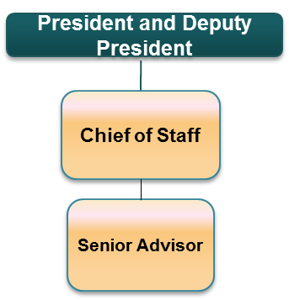**Duties and Responsibilities**

This is the highest grade in cadre and the officer will report directly to the President and Deputy President through the Chief of Staff. The Senior Advisor will be in-charge of the Office of Economic Affairs in the Executive Office of the President. The officer will be responsible for advice to the Presidency on economic developments and their impact on the programs and activities of the Government, and formulate and recommend national and international policy to promote economic development.

Specifically, the Senior Advisor will carry out the following duties and responsibilities:

1. Assist and advise the President in the preparation of the President’s Economic Brief providing an overview of the nation's economic progress;
2. Gather timely and authoritative information concerning economic developments and economic trends, both current and prospective, to analyze and interpret such information in the light of policy for the purpose of determining whether such developments and trends are interfering, or are likely to interfere, with the achievement of such policy, and to compile and submit to the President briefs relating to such developments and trends;
3. To appraise the various programs and activities of the National Government for the purpose of determining the extent to which such programs and activities are contributing, and the extent to which they are not contributing, to the achievement of such policy, and to make recommendations to the President with respect thereto;
4. To make and furnish such studies, reports thereon, and recommendations with respect to matters of national economic policy and legislation as the President may request.
5. Help ensure that policymakers across the executive branch work toward the President’s economic agenda.
6. Support public outreach activities conducted by executive departments and agencies designed to gather input from the public, from demonstration and pilot projects, and from public-private partnerships on the problems and priorities for policy measures designed to meet the President’s goals for improvement of the President’s economic agenda;
7. Represent the President at meetings, committees, boards and working groups as required, and at international meetings and conferences as necessary.

**Requirements for Appointment**

1. Masters degree in any of the following: Commerce, Economics, Public Finance, Business Administration or other equivalent qualification from a recognized institution;
2. Be of high integrity, commitment to, and demonstration of, ethical practices. A proven ability to create standards for ethical behaviour;
3. Ability to think analytically, within difficult constrains and develop solutions to problems;
4. Committed to excellence;
5. Ability to interact with peers and senior officials in a professional manner;
6. Have demonstrated outstanding professional and managerial competence as reflected in work performance and results;
7. Ability to inspire confidence in others and draw out the trust and best efforts of a team to complete the department’s mandate;
8. Have shown exemplary leadership qualities;
9. Demonstrated a clear understanding of economic affairs and practice as well as an understanding of national development policies, goals and objectives.
10. Ability for performance management tasks for both themselves and the officers directly reporting to them.

**Personal Qualities**

In addition to the above requirements, an officer must have the following qualities:

* High commitment and ability to set priorities;
* Ability to work with and manage virtual and flexible teams;
* Organizational, conceptual and analytical, managerial and decisive skills;
* Creativity, dynamism and innovation;
* Resource management skills;
* Interpersonal and communication skills;
* Integrity and commitment to producing results;
* Leadership, advocacy, relationship building and collaboration;
* Self drive and initiative to achieve expected results.

**Core Skills**

* People management
* Financial management
* Policy formulation and implementation
* Planning
* Organizing
* Directing
* Controlling
* Coordinating
* Strategy formulation

1. **Director – Job Group S**

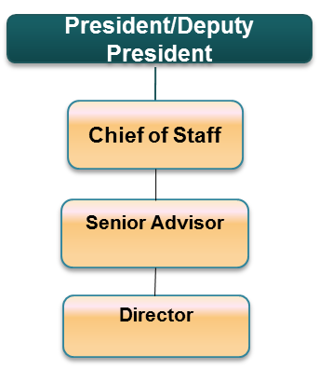The Director will deputise the Senior Advisor on Economic Affairs. Specific duties include:

1. Prepare economic briefs with regard to national and international positions and negotiations with multilateral and bilateral donors;
2. Evaluate economic, econometric and statistical advise;
3. Support the review of strategies, policies, programmes and initiatives developed by national government ministries, departments and agencies as well as the monitoring of their implementation for harmonization with the President’s economic agenda.
4. Support public outreach activities conducted by executive departments and agencies designed to gather input from the public, from demonstration and pilot projects, and from public-private partnerships on the problems and priorities for policy measures designed to meet the President’s goals for improvement of the President’s economic agenda.
5. Support the establishment of unit/departmental goals and objectives;
6. Support in establishing resources and budget for the Office of Economic Affairs at the EOP;
7. Manage responsibilities assigned within the Office of Economic Affairs;
8. Support the Senior Advisor in articulating economic policy and strategic direction;
9. Deputize the Senior Advisor in reviewing and reporting on Office’s progress as required;
10. Responsible for performance management tasks for the officers directly reporting to him.
11. Develop annual workplans and performance standards for the Office of Economic Affairs;

**Requirements for Appointment**

For appointment to this grade, an officer must have:

1. Masters degree in any of the following: Commerce, Economics, Public Finance, Business Administration or other equivalent qualification from a recognized institution;
2. Shown exemplary leadership qualities; and
3. Shown outstanding capability in economic analysis and practice.

**Personal Qualities**

In addition to the above requirements, an officer must have the following qualities:

* High commitment and ability to set priorities;
* Ability to work with and manage virtual and flexible teams;
* Ability to articulate, interpret and implement economic agenda, national and international policies and development Goals;
* Organizational, conceptual and analytical, managerial and decisive skills;
* Creativity and innovation;
* Technical problem solving;
* Resource management skills;
* Interpersonal and communication skills;
* Integrity and commitment to producing results;
* Leadership, advocacy, relationship building and collaboration;
* Self-Drive and initiative to achieve expected results.

**Core Skills**

* People management
* Financial management
* Policy formulation and implementation
* Planning
* Organizing
* Directing
* Controlling
* Coordinating
* Strategy formulation

1. **Deputy Director – Macroeconomic Division – Job Group R**

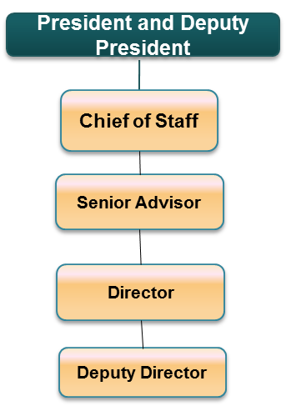The Deputy Director will be the Head of the Macroeconomic Division in the Office of Economic Affairs.

**Duties and Responsibilities**

The Deputy Director in charge of the Macroeconomic Division will be responsible for formulation and coordination of macro planning policies and strategies including:

1. The review of macro models developed by key statistical and economic planning agencies
2. Provide advice to relevant state department management of financial crisis and strengthen macroeconomic management.
3. Review implementation of monetary policy measures by key state department agencies.
4. Review foreign exchange reserve policies and practices, provide and discuss recommendations, and support their implementation.
5. Provide support to state departments in the development of national poverty reduction strategies and related documents, particularly in terms of linking macroeconomic trends and policy issues to poverty reduction.
6. Strengthen expertise and develop capacity in the macroeconomic and institutional reform dimensions of poverty reduction and economic development as appropriate.
7. The collection and collation of information and data for preparation of the relevant divisional reports and briefs.
8. Liaison and engagement with key offices including the office of the Kenya National Bureau of Statistics, Central Bank of Kenya, Kenya Revenue Authority and other state and non-state actors responsible for macroeconomic affairs.
9. Assist the Senior Advisor and Director on preparation and participation in public engagements, academic reviews and consultations on economic affairs as required.
10. Assign responsibilities to officers in the division;
11. Planning and managing the assignment schedule;
12. Proactively manage risks and issues – escalate to the Director and Senior Advisor as required;
13. Provide input into annual planning and forecasting;
14. Responsible for performance management tasks for both themselves and the officers directly reporting to them.

**Requirements for Appointment**

1. Masters degree in any of the following: Commerce, Economics, Public Finance, Business Administration or other equivalent qualification from a recognized institution;
2. Display a depth of understanding of economic affairs;

**Personal Qualities**

In addition to the above requirements, an officer must have the following qualities:

* High commitment and ability to set priorities;
* Ability to work with and manage matrix, virtual and flexible teams;
* Ability to articulate, interpret and implement National and International Policies and Development Goals;
* Organizational, conceptual and analytical, managerial and decisive skills.
* Creativity and innovation;
* Technical problem solving skills;
* Resource management skills;
* Interpersonal and communication skills;
* Integrity and commitment to producing results;
* Leadership, advocacy, relationship building and collaboration;
* Drive and initiative to achieve expected results.

1. **Assistant Director – Micro and Fiscal Division – Job Group Q**

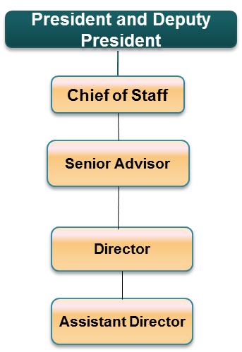The Assistant Director will be the Head of the Micro and Fiscal Division in the Office of Economic Affairs.

**Duties and Responsibilities:**

The Assistant Director in charge of the Micro and Fiscal Division will be responsible for:

1. Forecasting production and consumption of specific products and services based on records of past production and consumption and general economic conditions as required by the Senior Advisor
2. Analyze factors which determine economic growth and advice on policies to increase economic activity, investment, and new lines of production.
3. Examine statistical data on the exchange of goods and services among Kenya and its regional partners.
4. Study reports from central and private banks on the nature of money, credit and the operation of banks and other financial institutions to develop monetary policies and forecasts of financial activity.
5. Study mathematical formulae and statistical techniques and apply them to the testing and quantifying of economic theories and the solution of economic problems.
6. The collection and collation of information and data for preparation of the relevant divisional reports and briefs.
7. Liaison and engagement with key offices including the office of the Kenya National Bureau of Statistics and other state and non-state actors responsible for economic affairs.
8. Assist the Senior Advisor and Director on preparation and participation in public engagements, academic reviews and consultations on economic affairs as required.
9. Assign responsibilities to officers in the division;
10. Planning and managing the assignment schedule;
11. Proactively manage risks and issues – escalate to the Director and Senior Advisor as required;
12. Provide input into annual planning and forecasting;
13. Responsible for performance management tasks for both themselves and the officers directly reporting to them.

**Requirements for Appointment**

1. Masters degree in any of the following: Commerce, Economics, Public Finance, Business Administration or other equivalent qualification from a recognized institution;
2. Display a depth of understanding of economic affairs;

**Personal Qualities**

In addition to the above requirements, an officer must have the following qualities:

* High commitment and ability to set priorities;
* Ability to work with and manage matrix, virtual and flexible teams;
* Ability to articulate, interpret and implement National and International Policies and Development Goals;
* Organizational, conceptual and analytical, managerial and decisive skills.
* Creativity and innovation;
* Technical problem solving skills;
* Resource management skills;
* Interpersonal and communication skills;
* Integrity and commitment to producing results;
* Leadership, advocacy, relationship building and collaboration;
* Drive and initiative to achieve expected results.

1. **Officer – Job Group P**

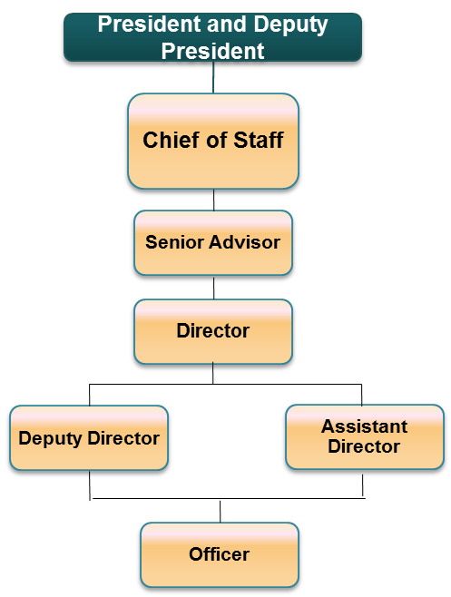The Officer will be report to the Deputy Director and Assistant Director in the Macroeconomic and Micro and Fiscal Division as appropriate.

**Duties and Responsibilities:**

1. Review of management of international reserves;
2. Macroeconomic analysis and projections;
3. Monetary policy operations;
4. Collect and manage a database of resources and information relevant to the mandate of the Office of Economic Affairs
5. Assist in development of relevant divisional reports and briefs.
6. Undertake research and information gathering on relevant economic aspects and projects as required.
7. Support the hosting of events and fora within the mandate of the Office of economic Affairs
8. Maintain all records and information of the division as appropriate.

**Requirements for Appointment**

1. Bachelors degree in Commerce, Economics, Public Finance, Business Administration or other equivalent qualification from a recognized institution;
2. Display a depth of understanding of economic affairs;

**Personal Qualities**

In addition to the above requirements, an officer must have the following qualities:

* High commitment and ability to set priorities;
* Ability to work with and manage matrix, virtual and flexible teams;
* Ability to articulate, interpret and implement National and International Policies and Development Goals;
* Organizational, conceptual and analytical, managerial and decisive skills.
* Creativity and innovation;
* Technical problem solving skills;
* Resource management skills;
* Interpersonal and communication skills;
* Integrity and commitment to producing results;
* Leadership, advocacy, relationship building and collaboration;
* Drive and initiative to achieve expected results.

1. **Intern**

This is the entry and training position. An officer at this level will be responsible for performing a variety of work of limited scope and under the guidance of a senior officer in either of the macroeconomic and micro/fiscal divisions. The scope and complexity of work will increase with experience and training but the officer will still be under close guidance where new tasks are involved. He/she will be responsible for safe custody of records and assets under him /her.

**OFFICE OF GOVERNANCE AFFAIRS**

**Background**

Promoting good governance in all its aspects, including by ensuring the rule of law, improving the efficiency and accountability of the public sector, and tackling corruption, as essential elements of a framework within which economies can prosper. The manifesto of the Jubilee coalition revolves around the President’s commitment to fight corruption and promote good governance. The manifesto is anchored upon transparent, accountable and participatory governance as a key ingredient to achieving poverty reduction and economic expansion.

The Office of Governance Affairs in the EOP within the Executive Office of the President will provide technical advice to the President, including contributing to the formulation of strategic approaches and coordinated programmatic inputs towards good governance.

**Organizational Structure**

1. **Senior Advisor/Head of Office - JOB GROUP ‘V’**

**Duties and Responsibilities**



This is the highest grade in cadre and the officer will report directly to the President and Deputy President through the Chief of Staff. The Senior Advisor will be in-charge of the Office of Governance Affairs in the Executive Office of the President. The Senior Advisor will be responsible for evaluating the effectiveness of agency programs, policies, and procedures to ensure consistency with the President's policies and advice the President on the same. In addition, the Senior Governance Advisor will advise the President on the improvement of policies, programmes and processes, and the effectiveness of the overall government structure. The Senior Governance Advisor will also advise on the improvement of administrative management, to develop better performance measures and coordinating mechanisms, and to reduce any unnecessary burdens on the public.

Specifically, the Senior Advisor will carry out the following duties and responsibilities:

1. Provide advice to the President on the conceptualisation, development and implementation of good governance strategies, policies and legislation in the political, economic, financial, performance, service delivery, and related spheres of the public service.
2. Oversee the design, implementation, and delivery of all activities targeting good governance, performance management and capacity development of government institutions with an emphasis on support for effective devolution as per constitutional stipulations.
3. Oversee public administration reform, public service delivery and capacity building including;
   1. Legislative review and strengthening;
   2. Monitoring of program quality assurance and improvement activities;
   3. Advise on local governance, devolution, and institution building;
   4. Advise on the strategies for achievement of transparency, accountability and service delivery performance;
4. Review, monitor and advice on the operations of public financial management processes and systems and recommend actions on prudent use of public financial resources.
5. Effectively deal with the critical and fast changing evolution of governance developments in the country;
6. Provide advice on the President on best practices as relates to the development of governance initiatives at various levels through written inputs such as comments, opinions and proposals on drafts, analytical papers on specific topics and regular consultations;
7. Support implementation of governance strategies, initiatives and measures through monitoring implementation of recommendations and proposals through frequent consultations with implementing agencies;
8. Provide coordination and liaison with other countries on the implementation of governance measures based on international best practices;
9. Provide advice to government on the development and implementation of sustainable ethical policies and strategies;
10. Advice the government’s approach to determining incentives for innovation in the areas of citizen-sate engagement and open government
11. Identify needed improvements in core government management functions.
12. To make and furnish such studies, reports thereon, and recommendations with respect to matters of governance policy and legislation as the President may request.
13. Help ensure that policymakers across the executive branch work toward the President’s governance agenda.
14. Support public outreach activities conducted by executive departments and agencies designed to gather input from the public, from demonstration and pilot projects, and from public-private partnerships on the problems and priorities for policy measures designed to meet the President’s goals for improvement of the President’s governance agenda;
15. Develop standards for public sector staffing, culture and capacities in line with the Presidency’s agenda for civil service reform.
16. Represent the President at meetings, committees, boards and working groups as required, and at international meetings and conferences as necessary.

**Requirements for Appointment**

1. Masters degree in any of the following: Governance, International Relations, Commerce, Economics, Public Finance, Social Sciences, Business Administration or other equivalent qualification from a recognized institution;
2. Be of high integrity, commitment to, and demonstration of, ethical practices. A proven ability to create standards for ethical behaviour;
3. Ability to think analytically, within difficult constrains and develop solutions to problems;
4. Committed to excellence;
5. Ability to interact with peers and senior officials in a professional manner;
6. Have demonstrated outstanding professional and managerial competence as reflected in work performance and results;
7. Ability to inspire confidence in others and draw out the trust and best efforts of a team to complete the department’s mandate;
8. Have shown exemplary leadership qualities;
9. Demonstrated a clear understanding of politics and practice as well as an understanding of national development policies, goals and objectives.
10. Ability for performance management tasks for both themselves and the officers directly reporting to them.

**Personal Qualities**

In addition to the above requirements, an officer must have the following qualities:

* High commitment and ability to set priorities;
* Ability to work with and manage virtual and flexible teams;
* Organizational, conceptual and analytical, managerial and decisive skills;
* Creativity, dynamism and innovation;
* Resource management skills;
* Interpersonal and communication skills;
* Integrity and commitment to producing results;
* Leadership, advocacy, relationship building and collaboration;
* Self drive and initiative to achieve expected results.

**Core Skills**

* People management
* Financial management
* Policy formulation and implementation
* Planning
* Organizing
* Directing
* Controlling
* Coordinating
* Strategy formulation

1. **Director – Job Group S**



The Director will deputise the Senior Advisor Governance Affairs. Specific duties include:

1. Coordinating clear and consistent communication between the Presidency & key relevant stakeholders on the Presidency’s Governance agenda
2. Support the Presidency’s Governance outreach activities.
3. Support the establishment of unit/departmental goals and objectives;
4. Support in establishing resources and budget for the Office of Governance Affairs at the EOP;
5. Manage responsibilities assigned within the Office of Governance Affairs;
6. Support the Senior Advisor in articulating Governance strategy direction;
7. Deputize the Senior Advisor in reviewing and reporting on Office’s progress as required;
8. Responsible for performance management tasks for the officers directly reporting to him.
9. Develop annual workplans and performance standards for the Office of Governance Affairs;

**Requirements for Appointment**

For appointment to this grade, an officer must have:

1. Masters degree in any of the following: Governance, Social Sciences, International Relations, Commerce, Economics, Public Finance, Business Administration or other equivalent qualification from a recognized institution.
2. Shown exemplary leadership qualities; and
3. Shown outstanding capability in politics and practice.

**Personal Qualities**

In addition to the above requirements, an officer must have the following qualities:

* High commitment and ability to set priorities;
* Ability to work with and manage virtual and flexible teams;
* Ability to articulate, interpret and implement constitutional and legal provisions, national and international policies and development Goals;
* Organizational, conceptual and analytical, managerial and decisive skills;
* Creativity and innovation;
* Technical problem solving;
* Resource management skills;
* Interpersonal and communication skills;
* Integrity and commitment to producing results;
* Leadership, advocacy, relationship building and collaboration;
* Self Drive and initiative to achieve expected results.

**Core Skills**

* People management
* Financial management
* Policy formulation and implementation
* Planning
* Organizing
* Directing
* Controlling
* Coordinating
* Strategy formulation

1. **Deputy Director – Institutional Governance Division – Job Group R**

The Deputy Director, Institutional Governance Division will support the Director in the Office of Governance Affairs.

**Duties and Responsibilities**

1. Develop and implement an overall Governance Strategy for the Government of Kenya, and the related Governance Action Plan (GAP) that will be the Presidency’s benchmark for governance reforms in all sectors.
2. Support the development of specific strategies for implementation of economic and fiscal governance reforms and initiatives to stem corruption as part of the Governance Strategy.
3. Support the implementation of governance programmes and activities including initiatives towards open government and public participation.
4. Support the review, monitoring, evaluation and reporting of the Governance Strategy and Action Plan, and other governance related commitments of the Government of Kenya to support the attainment of key objectives.
5. Provide technical and logistical support for capacity building requirements of implementing units.
6. Collaboration with other stakeholders in implementation and support of the Governance strategies
7. Development and support of the implementation of a capacity building programme as a regime for reinforcement of integrity principles amongst state departments.
8. The collection and collation of information and data for preparation of the relevant divisional reports and briefs.
9. Liaison and engagement with key Governance Parties and Non State actors on the Presidency’s Governance agenda
10. Prepare reports and briefs to the Director and Senior Advisor on varied Governance issues and strategic actions.
11. Maintain contact with Governance party leaders and practitioners and organize meetings and consultations with the Presidency as appropriate.
12. Planning and managing the assignment schedule;
13. Proactively manage risks and issues – escalate to the Director and Senior Advisor as required;
14. Provide input into annual planning and forecasting;
15. Responsible for performance management tasks for both themselves and the officers directly reporting to them.

**Requirements for Appointment**

1. Masters degree in any of the following: Governance Science, International Relations, Commerce, Economics, Public Finance, Business Administration or other equivalent qualification from a recognized institution;
2. Display a depth of understanding of Governance affairs;

**Personal Qualities**

In addition to the above requirements, an officer must have the following qualities:

* High commitment and ability to set priorities;
* Ability to work with and manage matrix, virtual and flexible teams;
* Ability to articulate, interpret and implement National and International Policies and Development Goals;
* Organizational, conceptual and analytical, managerial and decisive skills.
* Creativity and innovation;
* Technical problem solving skills;
* Resource management skills;
* Interpersonal and communication skills;
* Integrity and commitment to producing results;
* Leadership, advocacy, relationship building and collaboration;
* Drive and initiative to achieve expected results.

1. **Assistant Director – Public Sector Reforms Division - Job Group Q**

The Assistant Director will support the Director of Governance Affairs

**Duties and Responsibilities**

1. Support the Senior Advisor in developing the standards, culture and capacity requirements for public sector reforms in line with the Presidency’s agenda for the civil service
2. Backstop the development of public sector reform initiatives including change management and capacity building in line with the presidency’s agenda for public sector standards.
3. Monitor the implementation of public sector reforms and initiatives and report to the Director Governance Affairs.
4. The collection and collation of information and data for preparation of the relevant divisional reports and briefs.
5. Liaison and engagement with key offices including the state departments responsible for Public Service, capacity building and development as well as non-state actors.
6. Assign responsibilities to officers in the division;
7. Planning and managing the assignment schedule;
8. Proactively manage risks and issues – escalate to the Director and Senior Advisor as required;
9. Provide input into annual planning and forecasting;
10. Responsible for performance management tasks for both themselves and the officers directly reporting to them.

**Requirements for Appointment**

1. Masters degree in any of the following: Governance Science, International Relations, Commerce, Economics, Public Finance, Business Administration or other equivalent qualification from a recognized institution;
2. Familiar with public sector reforms and institutional governance;

**Personal Qualities**

In addition to the above requirements, an officer must have the following qualities:

* High commitment and ability to set priorities;
* Ability to work with and manage matrix, virtual and flexible teams;
* Ability to articulate, interpret and implement National and International Policies and Development Goals;
* Organizational, conceptual and analytical, managerial and decisive skills.
* Creativity and innovation;
* Technical problem solving skills;
* Resource management skills;
* Interpersonal and communication skills;
* Integrity and commitment to producing results;
* Leadership, advocacy, relationship building and collaboration;
* Drive and initiative to achieve expected results.

1. **Officer –– Job Group P**



The Officer will be report to the Deputy Director and Assistant Deputy Director as appropriate.

**Duties and Responsibilities**

The Officer will receive assignments as directed from the Deputy Director and Assistant Deputy Director and include:

1. Liaison and coalition building with other stakeholders and partners in the implementation of the public sector reforms and governance programmes and activities.
2. Monitor compliance and the enhancement of accountability and financial integrity in the use of public resources;
3. Collect and manage a database of resources and information relevant to the mandate of the Office of Governance Affairs
4. Assist in development of relevant divisional reports and briefs.
5. Undertake research and information gathering on relevant Governance aspects and projects as required.
6. Support the hosting of events and fora within the mandate of the Office of Governance Affairs
7. Maintain all records and information of the division as appropriate.

**Requirements for Appointment**

1. Bachelors degree in Governance, Social Sciences, International Relations, Commerce, Economics, Public Finance, Business Administration or other equivalent qualification from a recognized institution;
2. Display a depth of understanding of Governance affairs;
3. Familiar with Kenyan Governance dynamics and features of Governance engagement;

**Personal Qualities**

In addition to the above requirements, an officer must have the following qualities:

* High commitment and ability to set priorities;
* Ability to work with and manage matrix, virtual and flexible teams;
* Ability to articulate, interpret and implement National and International Policies and Development Goals;
* Organizational, conceptual and analytical, managerial and decisive skills.
* Creativity and innovation;
* Technical problem solving skills;
* Resource management skills;
* Interpersonal and communication skills;
* Integrity and commitment to producing results;
* Leadership, advocacy, relationship building and collaboration;
* Drive and initiative to achieve expected results.

1. **Intern**

This is the entry and training position. An officer at this level will be responsible for performing a variety of work of limited scope and under the guidance of a senior officer in either of the Institutional Governance and Public Sector Reforms divisions. The scope and complexity of work will increase with experience and training but the officer will still be under close guidance where new tasks are involved. He/she will be responsible for safe custody of records and assets under him /her.

**OFFICE OF CONSTITUTIONAL AND LEGISLATIVE AFFAIRS**

**Background**

The President is constitutionally obligated to “preserve, protect and defend” the Constitution in its entirety–not only executive power, but also judicial and Legislative power and constitutional limits on governmental power–and to enforce statutes enacted in accordance with the Constitution. The Office of Constitutional and Legislative Affairs in the EOP’s primary tasks are:

1. to support the President fulfil his constitutional duty of upholding the Constitution of Kenya and ensure the laws are faithfully executed in all of the varied work of the executive branch.
2. Operate as counsel to the Presidency and advice on all legal aspect and the legality of the Presidency’s decisions, ethical questions, financial disclosures, and conflicts of interest.
3. provide the legal expertise necessary to ensure the lawfulness of presidential and executive action and decisions in consultation with the office of the Attorney General
4. prepare for the President, the Deputy President, and the EOP senior staff a quarterly briefing memo analysing current developments in the legal sector.
5. Where necessary meet with non-state actors and government officials from other countries to discuss issues relating to global legal sector reforms and international best practice.

In its undertakings, the Office of Constitutional and Legislative Affairs will work closely with various government agencies, including the Attorney General, National Assembly, Parliamentary Service Commission, Kenya Law Reform Commission and other Constitutional Commissions on numerous constitutional, legal and Legislative policy matters.

**Organizational Structure**

1. **Senior Advisor/Head of Office - JOB GROUP ‘V’**

****This is the highest grade in cadre and the officer will report directly to the President and Deputy President through the Chief of Staff. The Senior Advisor will be in-charge of the Office of Constitutional and Legislative Affairs in the Executive Office of the President. The officer will be responsible for advice to the Presidency on conformity to constitutional stipulations, providing technical advice and process support on all issues regarding the Kenyan constitution, legislative and parliamentary affairs. The Senior Advisor will also operate as counsel to the presidency and advise on all legal aspects and the legality of decisions as appropriate. The Senior Advisor will manage information, produce written analysis, and ensure wide communication with all stakeholders with regards to these topics.  This Senior Advisor will routinely provide both written and oral briefings for the Presidency. The Senior Advisor will liaise with the various government agencies, including the office of the Attorney General, National Assembly, Parliamentary Service Commission, Ministry responsible for Justice and Constitutional Affairs, Kenya Law Reform Commission and other officials in carrying out his/her duties.

Specifically, the Senior Advisor will carry out the following duties and responsibilities:

1. Routinely advise the President on his conformity to constitutional stipulations, providing technical advice and process support on all issues regarding the constitution, transition and implementation schedules (as set out in the constitution).
2. Operate as counsel to the Presidency and advice on all legal aspect and the legality of the Presidency’s decisions, ethical questions, financial disclosures, and conflicts of interest.
3. Coordinate the preparation of the President’s annual report on the realization of national values and progress in the fulfilment of international obligations contemplated in Article 132 (1) (c) of the constitution;
4. Assist the President in forming opinions and positions and decision-making in relation to the performance of the President’s constitutional functions and powers.
5. Advise the presidency on all policy questions, legal issues and ethical distinctions arising out of their dual mandates as political and executive centres of authority.
6. Provide legislative clearance and coordination (review and clearance of all executive branch communications with parliament, including draft bills) to ensure consistency of legislative views and proposals with Presidential policy; and also coordinate and review of all significant national regulations by executive agencies, to reflect Presidential priorities.
7. Develop opinions on the conformity of laws with the Constitution; international treaties, as well as offering the President reasons to accept them or to refer them back the National Assembly.
8. Advise on the effects of legislation clearly and concisely, setting provisions in their legal and constitutional contexts.
9. Advise the President on best practices regarding key constitutional & transitional issues as they relate to interpreting & implementing the Constitution;
10. Review all bills presented for assent to the President and in consultation with the Attorney General, and advise the president accordingly.
11. Support the advancement of the President’s legislative agenda to the National Assembly and ensure that the President is kept up to date with critical Parliamentary proceedings.
12. Represent the President at meetings, committees, boards and working groups as required, and at international meetings and conferences as necessary.
13. Track and report on the state of implementation of key constitutional targets by the executive branch and the Presidency.
14. Advice on legal and constitutional aspects and implications of key strategic policy initiatives as requested by the president.
15. Provide legal opinions on any issues requested by the President
16. Review of Executive Orders and Cabinet Memoranda for conformity to the constitution, presidential legislative direction and strategy.

**Requirements for Appointment**

1. Masters degree in any of the following: Law or other equivalent qualification from a recognized institution;
2. Be of high integrity, commitment to, and demonstration of, ethical practices. A proven ability to create standards for ethical behaviour;
3. Ability to think analytically, within difficult constrains and develop solutions to problems;
4. Committed to excellence;
5. Ability to interact with peers and senior officials in a professional manner;
6. Have demonstrated outstanding professional and managerial competence as reflected in work performance and results;
7. Ability to inspire confidence in others and draw out the trust and best efforts of a team to complete the department’s mandate;
8. Have shown exemplary leadership qualities;
9. Demonstrated a clear understanding of constitutionalism, law and practice as well as an understanding of national development policies, goals and objectives.
10. Ability for performance management tasks for both themselves and the officers directly reporting to them.

**Personal Qualities**

In addition to the above requirements, an officer must have the following qualities:

* High commitment and ability to set priorities;
* Ability to work with and manage virtual and flexible teams;
* Organizational, conceptual and analytical, managerial and decisive skills;
* Creativity, dynamism and innovation;
* Resource management skills;
* Interpersonal and communication skills;
* Integrity and commitment to producing results;
* Leadership, advocacy, relationship building and collaboration;
* Self drive and initiative to achieve expected results.

**Core Skills**

* People management
* Financial management
* Policy formulation and implementation
* Planning
* Organizing
* Directing
* Controlling
* Coordinating
* Strategy formulation

1. **Director – Job Group S**



The Director will deputise the Senior Advisor on Constitutional and Legislative Affairs. Specific duties include:

1. Coordinate clear and consistent communication between the Presidency & key stakeholders on measures supporting the implementation of the constitution
2. Support the administration process of Presidential assent to the Bills passed by the Parliament.
3. Help ensure that policymakers across the executive branch work toward the President’s legislative agenda.
4. Support public outreach activities conducted by executive departments and agencies designed to gather input from the public, from demonstration and pilot projects, and from public-private partnerships on the problems and priorities for policy measures designed to meet the President’s goals for improvement of the President’s legislative agenda.
5. Support the establishment of unit/departmental goals and objectives;
6. Support in establishing resources and budget for the Office of Constitutional and Legal Affairs at the EOP;
7. Manage responsibilities assigned within the Office of Constitutional and Legislative Affairs;
8. Support the Senior Advisor in articulating constitutional and legislative policy and strategic direction;
9. Deputize the Senior Advisor in reviewing and reporting on Office’s progress as required;
10. Responsible for performance management tasks for the officers directly reporting to him.
11. Develop annual workplans and performance standards for the Office of Constitutional and Legislative Affairs;

**Requirements for Appointment**

For appointment to this grade, an officer must have:

1. Masters degree in any of the following: Social Science, Law or other equivalent qualification from a recognized institution.
2. Shown exemplary leadership qualities; and
3. Shown outstanding capability in law and practice.

**Personal Qualities**

In addition to the above requirements, an officer must have the following qualities:

* High commitment and ability to set priorities;
* Ability to work with and manage virtual and flexible teams;
* Ability to articulate, interpret and implement constitutional and legal provisions, national and international policies and development Goals;
* Organizational, conceptual and analytical, managerial and decisive skills;
* Creativity and innovation;
* Technical problem solving;
* Resource management skills;
* Interpersonal and communication skills;
* Integrity and commitment to producing results;
* Leadership, advocacy, relationship building and collaboration;
* Self Drive and initiative to achieve expected results.

**Core Skills**

* People management
* Financial management
* Policy formulation and implementation
* Planning
* Organizing
* Directing
* Controlling
* Coordinating
* Strategy formulation

1. **Deputy Director – Constitutional Division – Job Group R**



The Deputy Director will be the Head of the Constitutional Division in the Office of Constitutional and Legislative Affairs.

**Duties and Responsibilities**

The Deputy Director in charge of the Constitutional Division will be responsible for the review and analysis of constitutional aspects of the Presidency’s mandate including:

1. The collection and collation of information and data for preparation of the relevant divisional reports and briefs.
2. Liaison and engagement with key offices including the office of the Attorney General, Departments responsible for constitutional and legislative affairs and stakeholders.
3. Support processes of public consultation and engagement on constitutional interpretation and review in support of the Office of Constitutional and Legislative Affairs mandate.
4. Review all executive branch or parliamentary developed legislation and regulations for constitutional compliance.
5. Develop proposals for constitutional review as appropriate.
6. Monitor and report on constitutional implementation from all arms of government including national and county government institutions.
7. Review international treaties for their constitutional compliance
8. Assist the Senior Advisor and Director on preparation and participation in public engagements and consultations on constitutional aspects and interpretations.
9. Assign responsibilities to officers in the division;
10. Planning and managing the assignment schedule;
11. Proactively manage risks and issues – escalate to the Director and Senior Advisor as required;
12. Provide input into annual planning and forecasting;
13. Responsible for performance management tasks for both themselves and the officers directly reporting to them.

**Requirements for Appointment**

1. Masters degree in any of the following: Law or other equivalent qualification from a recognized institution;
2. Display a depth of understanding of constitutional and legal affairs;
3. Familiar with Kenyan legislative process and and legal drafting;

**Personal Qualities**

In addition to the above requirements, an officer must have the following qualities:

* High commitment and ability to set priorities;
* Ability to work with and manage matrix, virtual and flexible teams;
* Ability to articulate, interpret and implement National and International Policies and Development Goals;
* Organizational, conceptual and analytical, managerial and decisive skills.
* Creativity and innovation;
* Technical problem solving skills;
* Resource management skills;
* Interpersonal and communication skills;
* Integrity and commitment to producing results;
* Leadership, advocacy, relationship building and collaboration;
* Drive and initiative to achieve expected results.

1. **Assistant Director – Legislative Division – Job Group Q**

The Assistant Director will be the Head of the Legislative Division in the Office of Constitutional and Legislative Affairs.

**Duties and Responsibilities**

The Assistant Director in charge of the Legislative Division will be responsible for the review and analysis of constitutional aspects of the Presidency’s mandate including:

1. The collection and collation of information and data for preparation of the relevant divisional reports and briefs.
2. Review all executive branch or parliamentary developed legislation for compliance with the presidency’s policy and direction, their consistency and concurrence with other sectoral policies and prescriptions.
3. Review international treaties for their legislative compliance.
4. Develop proposals for legislative review as appropriate.
5. Liaison and engagement with key offices including the office of the Attorney General, Departments responsible for constitutional and legislative affair, the National Assembly and stakeholders.
6. Prepare briefs for the president on critical Parliamentary proceedings specific to their legislative agenda.
7. Support processes of public consultation and engagement on legislative interpretation and review in support of the Office of Constitutional and Legislative Affairs mandate.
8. Assist the Senior Advisor and Director on preparation and participation in public engagements and consultations on legislative aspects and interpretations.
9. Assign responsibilities to officers in the division;
10. Planning and managing the assignment schedule;
11. Proactively manage risks and issues – escalate to the Director and Senior Advisor as required;
12. Provide input into annual planning and forecasting;
13. Responsible for performance management tasks for both themselves and the officers directly reporting to them.

**Requirements for Appointment**

1. Masters degree in any of the following: Law or other equivalent qualification from a recognized institution;
2. Display a depth of understanding of constitutional and legal affairs;
3. Familiar with Kenyan legislative process and legal drafting;

**Personal Qualities**

In addition to the above requirements, an officer must have the following qualities:

* High commitment and ability to set priorities;
* Ability to work with and manage matrix, virtual and flexible teams;
* Ability to articulate, interpret and implement National and International Policies and Development Goals;
* Organizational, conceptual and analytical, managerial and decisive skills.
* Creativity and innovation;
* Technical problem solving skills;
* Resource management skills;
* Interpersonal and communication skills;
* Integrity and commitment to producing results;
* Leadership, advocacy, relationship building and collaboration;
* Drive and initiative to achieve expected results.

1. **Officer – Constitutional Division – Job Group P**

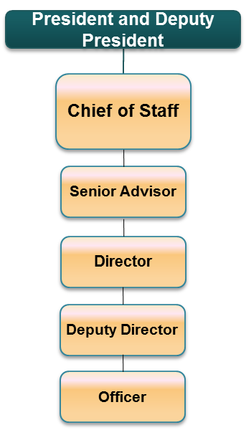The Officer will be report to the Deputy Director – Constitutional Division.

**Duties and Responsibilities**

The Officer will receive assignments as directed from the Deputy Director – Constitutional Division and include:

1. Collect and manage a database of resources and information relevant to the mandate of the Office of Constitutional and Legislative Affairs
2. Assist the Deputy Director in development of relevant divisional reports and briefs.
3. Undertake research and information gathering on relevant constitutional and legislative aspects and projects as required.
4. Support the hosting of events and fora within the mandate of the Office of constitutional and Legislative Affairs
5. Maintain all records and information of the division as appropriate.
6. **Requirements for Appointment**
7. Bachelors degree in Law or other equivalent relevant qualification from a recognized institution;
8. Display a depth of understanding of constitutional and legal affairs;
9. Familiar with Kenyan legislative process and legal drafting;

**Personal Qualities**

In addition to the above requirements, an officer must have the following qualities:

* High commitment and ability to set priorities;
* Ability to work with and manage matrix, virtual and flexible teams;
* Ability to articulate, interpret and implement National and International Policies and Development Goals;
* Organizational, conceptual and analytical, managerial and decisive skills.
* Creativity and innovation;
* Technical problem solving skills;
* Resource management skills;
* Interpersonal and communication skills;
* Integrity and commitment to producing results;
* Leadership, advocacy, relationship building and collaboration;
* Drive and initiative to achieve expected results.

1. **Officer – Legislative Division – Job Group P**

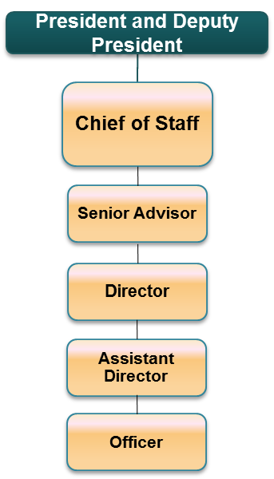 The officer will report to the Assistant Director – Legislative Division.

**Duties and Responsibilities:**

The Officer will receive assignments as directed from the Assistant Director – Legislative Division and include:

1. Collect and manage a database of resources and information relevant to the mandate of the Office of Constitutional and Legislative Affairs
2. Assist the Assistant Director in development of relevant divisional reports and briefs.
3. Undertake research and information gathering on relevant constitutional and legislative aspects and projects as required.
4. Support the hosting of events and fora within the mandate of the Office of constitutional and Legislative Affairs
5. Maintain all records and information of the division as appropriate.
6. Liaise with relevant technical leads from stakeholder state and non-state institutions.
7. Support the development of policy proposals on review of legislative and regulatory prescriptions.
8. Conduct legal research, including legal comparative research, to make recommendations for law reform.
9. Investigate and develop primary and subordinate legislation.
10. Review and amend existing primary and subordinate legislation.
11. Advise in respect of legislative proposals relating to the line function of the department.

**Requirements for Appointment**

1. Bachelors degree in Law or other equivalent relevant qualification from a recognized institution;
2. Display a depth of understanding of constitutional and legal affairs;
3. Familiar with Kenyan legislative process and legal drafting;

**Personal Qualities**

In addition to the above requirements, an officer must have the following qualities:

* High commitment and ability to set priorities;
* Ability to work with and manage matrix, virtual and flexible teams;
* Ability to articulate, interpret and implement National and International Policies and Development Goals;
* Organizational, conceptual and analytical, managerial and decisive skills.
* Creativity and innovation;
* Technical problem solving skills;
* Resource management skills;
* Interpersonal and communication skills;
* Integrity and commitment to producing results;
* Leadership, advocacy, relationship building and collaboration;
* Drive and initiative to achieve expected results.

1. **Intern**

This is the entry and training position. An officer at this level will be responsible for performing a variety of work of limited scope and under the guidance of a senior officer in either of the Constitutional and Legislative divisions. The scope and complexity of work will increase with experience and training but the officer will still be under close guidance where new tasks are involved. He/she will be responsible for safe custody of records and assets under him /her.

**OFFICE OF POLITICAL AFFAIRS**

**Background**

The Office of Political Affairs within the Executive Office of the President will provide technical advice to the President, including contributing to the formulation of strategic approaches on the political aspects of the President’s agenda. These will include regular briefs and policy positions with regard to political matters. The office will be responsible for monitoring all parliamentary political parties, and political events in the country with the view to identifying politically problematic issues meriting the President’s attention and advising on the same.

**Organizational Structure**

1. **Senior Advisor/Head of Office - JOB GROUP ‘V’**

**Duties and Responsibilities**

This is the highest grade in cadre and the officer will report directly to the President and Deputy President. The Senior Advisor will be in-charge of the Office of Political Affairs in the Executive Office of the President. The Senior Advisor will be responsible for technical advice to the President, including contributing to the formulation of strategic approaches on the political aspects of the President’s agenda. The Office of Political Affairs in the EOP will work closely with various government agencies, including the Registrar of Political Parties, Parliamentary Service Commission, relevant ministries and agencies. The Office of Political Affairs will also directly engage with political party officials and non-state actors in meeting with the presidency’s agenda and mandate.

Specifically, the Senior Advisor will carry out the following duties and responsibilities:

1. Monitor developments/issues in intergovernmental relations, analyse these developments to determine their implications for the president’s political agenda, and develops viable options and recommendations, actions and/or strategies.
2. Provide the President with regular briefs and policy positions with regard to political matters;
3. Act as liaison between the President and political parties, Governors and County Assemblies;
4. Maintain close contact with all parliamentary political parties with the view to facilitating consultation with the President.
5. Monitor political events in the country with the view to identify politically problematic issues meriting the President’s attention.
6. Establish contacts in all regions with different socio-political opinion to obtain balanced view of the problems and issues relevant to the region;
7. Attend all meetings which the President the President might have with leaders of political parties, parliament etc.
8. Maintain contact with political leaders and facilitate their consultation with the President on issues of interest to them that warrants the President’s attention;
9. Conduct thorough political research and preparing briefs to keep the President abreast of political developments, nationally, regionally and internationally;
10. Carry out any other instructions from the President.
11. Represent the President at meetings, committees, boards and working groups as required, and at international meetings and conferences as necessary.

**Requirements for Appointment**

1. Masters degree in any of the following: Political Science, International Relations, Commerce, Economics, Public Finance, Business Administration or other equivalent qualification from a recognized institution;
2. Be of high integrity, commitment to, and demonstration of, ethical practices. A proven ability to create standards for ethical behaviour;
3. Ability to think analytically, within difficult constrains and develop solutions to problems;
4. Committed to excellence;
5. Ability to interact with peers and senior officials in a professional manner;
6. Have demonstrated outstanding professional and managerial competence as reflected in work performance and results;
7. Ability to inspire confidence in others and draw out the trust and best efforts of a team to complete the department’s mandate;
8. Have shown exemplary leadership qualities;
9. Demonstrated a clear understanding of politics and practice as well as an understanding of national development policies, goals and objectives.
10. Ability for performance management tasks for both themselves and the officers directly reporting to them.

**Personal Qualities**

In addition to the above requirements, an officer must have the following qualities:

* High commitment and ability to set priorities;
* Ability to work with and manage virtual and flexible teams;
* Organizational, conceptual and analytical, managerial and decisive skills;
* Creativity, dynamism and innovation;
* Resource management skills;
* Interpersonal and communication skills;
* Integrity and commitment to producing results;
* Leadership, advocacy, relationship building and collaboration;
* Self drive and initiative to achieve expected results.

**Core Skills**

* People management
* Financial management
* Policy formulation and implementation
* Planning
* Organizing
* Directing
* Controlling
* Coordinating
* Strategy formulation

1. **Director – Job Group S**

The Director will deputise the Senior Advisor Political Affairs. Specific duties include:

1. Coordinating clear and consistent communication between the Presidency & key relevant stakeholders on the Presidency’s political agenda
2. Support the Presidency’s political outreach activities.
3. Support the establishment of unit/departmental goals and objectives;
4. Support in establishing resources and budget for the Office of Political Affairs at the EOP;
5. Manage responsibilities assigned within the Office of Political Affairs;
6. Support the Senior Advisor in articulating political strategy direction;
7. Deputize the Senior Advisor in reviewing and reporting on Office’s progress as required;
8. Responsible for performance management tasks for the officers directly reporting to him.
9. Develop annual workplans and performance standards for the Office of Political Affairs;

**Requirements for Appointment**

For appointment to this grade, an officer must have:

1. Masters degree in any of the following: Political Science, International Relations, Commerce, Economics, Public Finance, Business Administration or other equivalent qualification from a recognized institution.
2. Shown exemplary leadership qualities; and
3. Shown outstanding capability in politics and practice.

**Personal Qualities**

In addition to the above requirements, an officer must have the following qualities:

* High commitment and ability to set priorities;
* Ability to work with and manage virtual and flexible teams;
* Ability to articulate, interpret and implement constitutional and legal provisions, national and international policies and development Goals;
* Organizational, conceptual and analytical, managerial and decisive skills;
* Creativity and innovation;
* Technical problem solving;
* Resource management skills;
* Interpersonal and communication skills;
* Integrity and commitment to producing results;
* Leadership, advocacy, relationship building and collaboration;
* Self Drive and initiative to achieve expected results.

**Core Skills**

* People management
* Financial management
* Policy formulation and implementation
* Planning
* Organizing
* Directing
* Controlling
* Coordinating
* Strategy formulation

1. **Deputy Director – Job Group R**

The Deputy Director will support the Director in the Office of Political Affairs.

**Duties and Responsibilities**

1. The collection and collation of information and data for preparation of the relevant divisional reports and briefs.
2. Liaison and engagement with key offices including the office of the Registrar of Political Parties, Parliamentary Service Commission, relevant ministries and agencies and stakeholders.
3. Support liaison with the National Assembly on the Presidency’s political agenda and engagements.
4. Assign responsibilities to officers in the division;
5. Planning and managing the assignment schedule;
6. Proactively manage risks and issues – escalate to the Director and Senior Advisor as required;
7. Provide input into annual planning and forecasting;
8. Responsible for performance management tasks for both themselves and the officers directly reporting to them.

**Requirements for Appointment**

1. Masters degree in any of the following: Political Science, International Relations, Commerce, Economics, Public Finance, Business Administration or other equivalent qualification from a recognized institution;
2. Display a depth of understanding of political affairs;
3. Familiar with Kenyan political dynamics and features of political engagement;

**Personal Qualities**

In addition to the above requirements, an officer must have the following qualities:

* High commitment and ability to set priorities;
* Ability to work with and manage matrix, virtual and flexible teams;
* Ability to articulate, interpret and implement National and International Policies and Development Goals;
* Organizational, conceptual and analytical, managerial and decisive skills.
* Creativity and innovation;
* Technical problem solving skills;
* Resource management skills;
* Interpersonal and communication skills;
* Integrity and commitment to producing results;
* Leadership, advocacy, relationship building and collaboration;
* Drive and initiative to achieve expected results.

1. **Assistant Director –**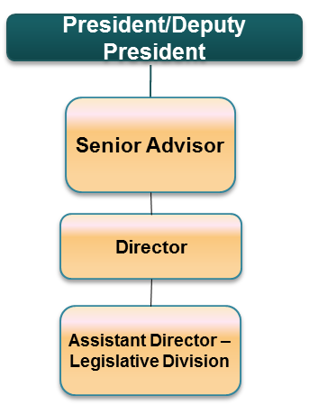The Assistant Director will support the Director of Political Affairs

**Duties and Responsibilities**

1. The collection and collation of information and data for preparation of the relevant divisional reports and briefs.
2. Liaison and engagement with key Political Parties and Non State actors on the Presidency’s political agenda
3. Prepare reports and briefs to the Director and Senior Advisor on varied political issues and strategic actions.
4. Maintain contact with political party leaders and practitioners and organize meetings and consultations with the Presidency as appropriate.
5. Planning and managing the assignment schedule;
6. Proactively manage risks and issues – escalate to the Director and Senior Advisor as required;
7. Provide input into annual planning and forecasting;
8. Responsible for performance management tasks for both themselves and the officers directly reporting to them.

**Requirements for Appointment**

1. Masters degree in any of the following: Political Science, International Relations, Commerce, Economics, Public Finance, Business Administration or other equivalent qualification from a recognized institution;
2. Display a depth of understanding of political affairs;
3. Familiar with Kenyan political dynamics and features of political engagement;

**Personal Qualities**

In addition to the above requirements, an officer must have the following qualities:

* High commitment and ability to set priorities;
* Ability to work with and manage matrix, virtual and flexible teams;
* Ability to articulate, interpret and implement National and International Policies and Development Goals;
* Organizational, conceptual and analytical, managerial and decisive skills.
* Creativity and innovation;
* Technical problem solving skills;
* Resource management skills;
* Interpersonal and communication skills;
* Integrity and commitment to producing results;
* Leadership, advocacy, relationship building and collaboration;
* Drive and initiative to achieve expected results.

1. **Officer –– Job Group P**

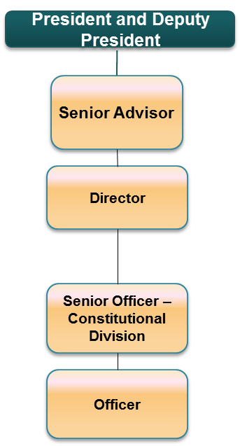 The Officer will be report to the Deputy Director and Assistant Deputy Director as appropriate

**Duties and Responsibilities**

The Officer will receive assignments as directed from the Deputy Director and Assistant Deputy Director and include:

1. Collect and manage a database of resources and information relevant to the mandate of the Office of Political Affairs
2. Assist the Deputy Director in development of relevant divisional reports and briefs.
3. Undertake research and information gathering on relevant political aspects and projects as required.
4. Support the hosting of events and fora within the mandate of the Office of Political Affairs
5. Maintain all records and information of the division as appropriate.

**Requirements for Appointment**

1. Bachelors degree in Political Science, International Relations, Commerce, Economics, Public Finance, Business Administration or other equivalent qualification from a recognized institution;
2. Display a depth of understanding of political affairs;
3. Familiar with Kenyan political dynamics and features of political engagement;

**Personal Qualities**

In addition to the above requirements, an officer must have the following qualities:

* High commitment and ability to set priorities;
* Ability to work with and manage matrix, virtual and flexible teams;
* Ability to articulate, interpret and implement National and International Policies and Development Goals;
* Organizational, conceptual and analytical, managerial and decisive skills.
* Creativity and innovation;
* Technical problem solving skills;
* Resource management skills;
* Interpersonal and communication skills;
* Integrity and commitment to producing results;
* Leadership, advocacy, relationship building and collaboration;
* Drive and initiative to achieve expected results.

1. **Intern**

This is the entry and training position. An officer at this level will be responsible for performing a variety of work of limited scope and under the guidance of a senior officer in either of the Constitutional and Legislative divisions. The scope and complexity of work will increase with experience and training but the officer will still be under close guidance where new tasks are involved. He/she will be responsible for safe custody of records and assets under him /her.

**OFFICE OF COMMUNICATIONS**

The Office of Communications is responsible for handling all media related matters and liaise with all major media agencies locally and internationally for effective communication of the Presidency’s policy and administrative positions. The office will prepare and organize for all press releases, gazettes and prepare speeches, addresses, statements and interviews given by the Presidency.



1. **Senior Advisor Communication – JOB GROUP V**

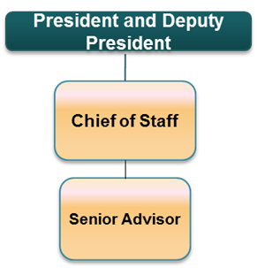**Duties & Responsibilities**

This is the highest grade in the Communications Office. The Senior Advisor Communications is the advisor to the Presidency on Communication matters. The office of the Senior Advisor is responsible for formulation, and implementation of Government’s Communication strategy and ensures that the administration's message has been delivered successfully.

Specifically the Senior Advisor Communications will carry out the following duties and responsibilities:

1. Routinely advice the President on communication aspects.
2. Ensure that all aspects of communications are covered to ensure that the administration's message has been delivered successfully.
3. Devise a communications strategy to promote the President's agenda throughout all media outlets.
4. Act as a liaison between the President and Media with a view of facilitating consultation with the President.
5. Work closely with cabinet level departments and other executive agencies in order to create a coherent strategy through which the President's message can be disseminated.
6. Formulate and implement the communication policy.
7. Coordinate research and development of emerging issues with respect to communications.
8. Ensure monitoring of information, public communication policies and programs and review them as appropriate.

**Requirements for Appointment**

1. Requisite experience in any of the following: Communication, Communication Studies, Public Relations, Journalism, International Relations or Social Sciences;
2. In addition they must have at
3. Ability to interact with peers and senior officials in a professional manner;
4. Have demonstrated outstanding professional and managerial competence as reflected in work performance and results;
5. Ability to inspire confidence in others and draw out the trust and best efforts of a team to complete the department’s mandate;
6. Have shown exemplary leadership qualities;
7. Demonstrated a clear understanding of communication and practice as well as understanding of national development policies, goals and objectives.
8. Ability for performance management tasks for both themselves and the officers directly reporting to them.

**Personal Qualities**

In addition to the above requirements, an officer must have the following qualities;

* High commitment and ability to set priorities;
* Ability to work with and manage virtual and flexible teams;
* Organizational, conceptual and analytical, managerial and decisive skills;
* Creativity, dynamism and innovation;
* Resource management skills;
* Interpersonal and communication skills;
* Integrity and commitment to producing results;
* Leadership, advocacy, relationship building and collaboration;
* Self-drive and initiative to achieve expected results.

**Core Skills**

* People management
* Financial management
* Policy formulation and implementation
* Planning
* Organizing
* Directing
* Controlling
* Coordinating
* Strategy formulation

**Secretary Communication (State House Spokesperson): - JOB GROUP T**

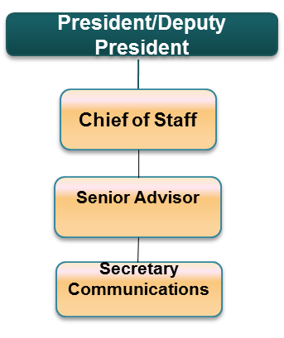The Secretary Communication will deputise the Senior Advisor Communications.

Specific duties include:

1. Act as Spokesperson for the President and the administration.
2. Interact with the media, and deal with the State House Correspondents on a daily basis, generally in a daily/weekly press briefing.
3. Serve as the key spokesman and media contact for the organization.
4. Collect information about actions and events within the President's administration and issues the administration's reactions to developments around the country and the world.
5. Be in charge of managing the relationship between the President and media.

**Requirements for Appointment**

For appointment to this grade, an officer must have:

1. Requisite experience in any of the following: Communication, Communication Studies, Public Relations, Journalism, International Relations or Social Sciences;
2. In addition they must have at least 5 years of experience in the Communinication Industry;
3. Be of high integrity, commitment to and demonstration of, ethical practices. A proven ability to create standards for ethical behavior;
4. Ability to think analytically, within difficult constrains and develop solutions to problems;
5. Committed to excellence;
6. Ability to interact with peers and senior officials in a professional manner;
7. Have demonstrated outstanding professional and managerial competence as reflected in work performance and results;
8. Ability to inspire confidence in others and draw out the trust and best efforts of a team to complete the department’s mandate;
9. Have shown exemplary leadership qualities;
10. Demonstrated a clear understanding of communication and practice as well as understanding of national development policies, goals and objectives.
11. Ability for performance management tasks for both themselves and the officers directly reporting to them.

**Personal Qualities**

In addition to the above requirements, an officer must have the following qualities;

* High commitment and ability to set priorities;
* Ability to work with and manage virtual and flexible teams;
* Organizational, conceptual and analytical, managerial and decisive skills;
* Creativity, dynamism and innovation;
* Resource management skills;
* Interpersonal and communication skills;
* Integrity and commitment to producing results;
* Leadership, advocacy, relationship building and collaboration;
* Self-drive and initiative to achieve expected results.

**Core Skills**

* People management
* Financial management
* Policy formulation and implementation
* Planning
* Organizing
* Directing
* Controlling
* Coordinating
* Strategy formulation

**Director External Media Relations – JOB GROUP S**

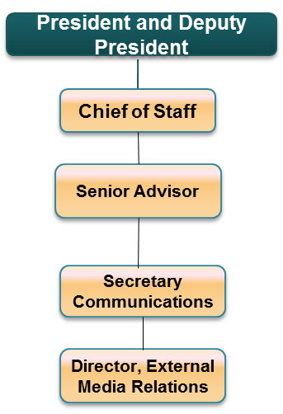

The Director External Media Relations will deputise the Secretary Communications.

Specific duties will include:

1. Coordinate clear and consistent communication between the Presidency and external media stakeholders as the direct contact;
2. Support the Presidency’s media outreach activities.
3. Support the establishment of unit/departmental goals and objectives;
4. Support in establishing resources and budget for the Communication Office at the EOP;
5. Manage responsibilities assigned within the Communications Office;
6. Support the Senior Advisor in articulating communication strategy direction;
7. Deputize the Secretary Communication in reviewing and reporting on Office’s progress as required;
8. Responsible for performance management tasks for the officers directly reporting to him/her.
9. Develop annual work-plans and performance standards for the Communications Office;
10. Provide a summary of the President’s schedule for the day for dissemination by the Secretary Communication, whom the president has seen, or had communication;
11. Deputize the Secretary Communication by communicating the official position of the administration on the news of the day.
12. Offer guidance and advice on methods for dealing with the media.
13. Manage the briefing room.

**Requirements for Appointment**

For appointment to this grade, an officer must have:

1. Requisite experience in any of the following: Communication, Communication Studies, Public Relations, Journalism, International Relations or Social Sciences;
2. In addition they must have at least 5 years of experience in the Communinication Industry;
3. Shown exemplary leadership qualities;
4. Shown outstanding capabilities in communications;
5. Be of high integrity, commitment to and demonstration of, ethical practices. A proven ability to create standards for ethical behavior;
6. Ability to think analytically, within difficult constrains and develop solutions to problems;
7. Committed to excellence;
8. Ability to interact with peers and senior officials in a professional manner;

**Personal Qualities**

In addition to the above requirements, an officer must have the following qualities;

* High commitment and ability to set priorities;
* Ability to work with and manage virtual and flexible teams;
* Organizational, conceptual and analytical, managerial and decisive skills;
* Creativity, dynamism and innovation;
* Resource management skills;
* Interpersonal and communication skills;
* Integrity and commitment to producing results;
* Leadership, advocacy, relationship building and collaboration;
* Self-drive and initiative to achieve expected results.

**Core Skills**

* People management
* Financial management
* Policy formulation and implementation
* Planning
* Organizing
* Directing
* Controlling
* Coordinating
* Strategy formulation

**Deputy Director Media Liaison – JOB GROUP R**

The Deputy Director Media Liaison will deputise the Director External Media Relations.

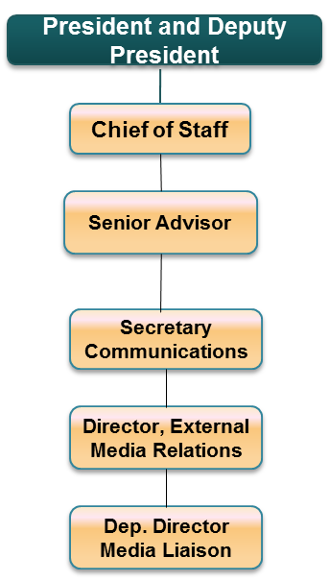

Specific duties will include:

1. Provide administrative support for coordination between the Director External Media and the State House Press Corps;
2. The Deputy Director Media Liaison will also update and maintain the database of media contact for corporate communication liaison and relationship management;
3. Carry out research on both local and international press on possible causes of negative publicity on the EOP and develop appropriate interventions;
4. Assign responsibilities to officers in the division;
5. Planning managing the assignment schedule;
6. Develop proposals for communication strategy;
7. Proactively manage risks and issues – escalate to the Director, Communications Secretary and Senior Advisor Communication as required;
8. Provide input into annual planning and forecasting;
9. Responsible for performance management tasks for both themselves and the officers directly reporting to them.

**Requirements for Appointment**

For appointment to this grade, an officer must have:

1. Requisite experience in any of the following: Communication, Communication Studies, Public Relations, Journalism, International Relations or Social Sciences;
2. In addition they must have at least 5 years of experience in the Communinication Industry;
3. Shown exemplary leadership qualities;
4. Shown outstanding capabilities in communications;
5. Be of high integrity, commitment to and demonstration of, ethical practices. A proven ability to create standards for ethical behavior;
6. Ability to think analytically, within difficult constrains and develop solutions to problems;
7. Committed to excellence;
8. Possess strong leadership skills required at that level;
9. Possess good oral and written communication skills in both English and Kiswahili; and
10. Ability to interact with peers and senior officials in a professional manner;

**Personal Qualities**

In addition to the above requirements, an officer must have the following qualities;

* High commitment and ability to set priorities;
* Ability to work with and manage virtual and flexible teams;
* Organizational, conceptual and analytical, managerial and decisive skills;
* Creativity, dynamism and innovation;
* Resource management skills;
* Interpersonal and communication skills;
* Integrity and commitment to producing results;
* Leadership, advocacy, relationship building and collaboration;
* Self-drive and initiative to achieve expected results.

**Director Speech Writing and Research – JOB GROUP S**

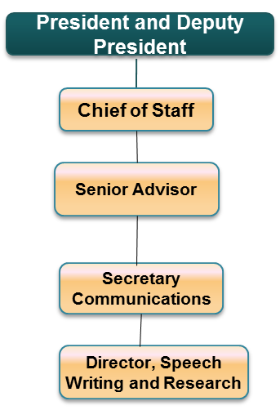The Director Speech Writing & Research will deputise the Secretary Communications.

Specific duties will include:

1. The Director will oversee the writing of all Presidential Speeches;
2. Conceptualize the broad framework of points or messages, research on topics and blend points, themes, positions, and messages with own research to create an informative, original and authentic speech for the President and First Lady.
3. Support the Presidency’s media outreach activities.
4. Support the establishment of unit/departmental goals and objectives;
5. Support in establishing resources and budget for the Communication Office at the EOP;
6. Manage responsibilities assigned within the Communications Office;
7. Support the Senior Advisor in articulating communication strategy direction;
8. Deputize the Secretary Communication in reviewing and reporting on Office’s progress as required;
9. Responsible for performance management tasks for the officers directly reporting to him/her.
10. Develop annual work-plans and performance standards for the Communications Office;

**Requirements for Appointment**

For appointment to this grade, an officer must have:

1. Requisite experience in any of the following: Communication, Communication Studies, Public Relations, Journalism, International Relations or Social Sciences;
2. In addition they must have at least 5 years of experience in the Communinication Industry;
3. Shown exemplary leadership qualities;
4. Shown outstanding capabilities in communications;
5. Be of high integrity, commitment to and demonstration of, ethical practices;
6. A proven ability to create standards for ethical behavior;
7. Ability to think analytically, within difficult constrains and develop solutions to problems;
8. Committed to excellence;
9. Ability to interact with peers and senior officials in a professional manner;

**Personal Qualities**

In addition to the above requirements, an officer must have the following qualities;

* High commitment and ability to set priorities;
* Ability to work with and manage virtual and flexible teams;
* Organizational, conceptual and analytical, managerial and decisive skills;
* Creativity, dynamism and innovation;
* Resource management skills;
* Interpersonal and communication skills;
* Integrity and commitment to producing results;
* Leadership, advocacy, relationship building and collaboration;
* Self-drive and initiative to achieve expected results.

**Core Skills**

* People management
* Financial management
* Policy formulation and implementation
* Planning
* Organizing
* Directing
* Controlling
* Coordinating
* Strategy formulation

**Deputy Director Speech Writer - JOB GROUP R**

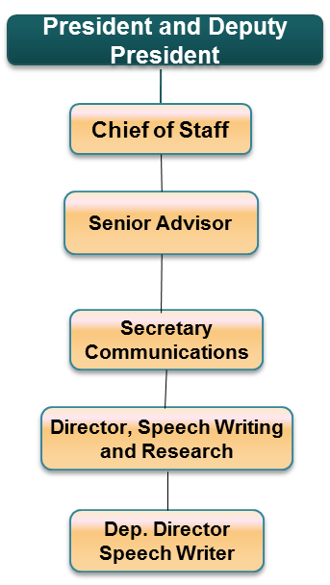The Deputy Director Speech Writer will deputise the Director Speech Writing and Research.

Specific duties will include:

1. Draft version of speeches for consideration by the office of Director Speech Writing and Research.
2. Make notes on any revisions or changes that are requested by the Director Speech Writing and Research.
3. Assign responsibilities to officers in the division;
4. Planning managing the assignment schedule;
5. Develop proposals for communication strategy;
6. Proactively manage risks and issues – escalate to the Director, Communications Secretary and Senior Advisor Communication as required;
7. Provide input into annual planning and forecasting;
8. Responsible for performance management tasks for both themselves and the officers directly reporting to them.

**Requirements for Appointment**

For appointment to this grade, an officer must have:

1. Requisite experience in any of the following: Communication, Communication Studies, Public Relations, Journalism, International Relations or Social Sciences;
2. In addition they must have at least 5 years of experience in the Communinication Industry;
3. Shown exemplary leadership qualities;
4. Shown outstanding capabilities in communications;
5. Be of high integrity, commitment to and demonstration of, ethical practices. A proven ability to create standards for ethical behavior;
6. Ability to think analytically, within difficult constrains and develop solutions to problems;
7. Committed to excellence;
8. Possess strong leadership skills required at that level;
9. Possess good oral and written communication skills in both English and Kiswahili; and
10. Ability to interact with peers and senior officials in a professional manner;

**Personal Qualities**

In addition to the above requirements, an officer must have the following qualities;

* High commitment and ability to set priorities;
* Ability to work with and manage virtual and flexible teams;
* Organizational, conceptual and analytical, managerial and decisive skills;
* Creativity, dynamism and innovation;
* Resource management skills;
* Interpersonal and communication skills;
* Integrity and commitment to producing results;
* Leadership, advocacy, relationship building and collaboration;
* Self-drive and initiative to achieve expected results.

**Deputy Director Principal Research: - JOB GROUP R**

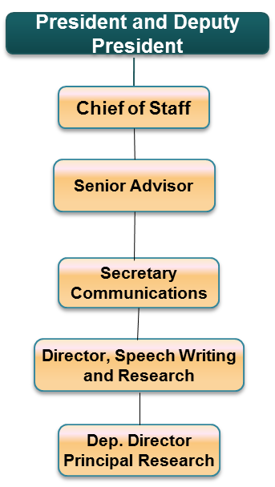The Deputy Director Principal Research will deputise the Director Speech Writing and Research.

Specific duties will include:

1. Oversee all elements of research, analytics, media monitoring, library services and archive services;
2. Ensure systematic investigation into a study of materials and sources in order to establish facts;
3. Ensure that the Presidency is kept updated through constant media monitoring of all mediums (TV, Radio, Print and Internet);
4. Keep a library of books, periodicals, films, and music for use or borrowing by the institution of the Presidency.
5. Keep a collection of historical documents or records providing information about the institution of the Presidency.
6. Assign responsibilities to officers in the division;
7. Planning managing the assignment schedule;
8. Develop proposals for communication strategy;
9. Proactively manage risks and issues – escalate to the Director, Communications Secretary and Senior Advisor Communication as required;
10. Provide input into annual planning and forecasting;
11. Responsible for performance management tasks for both themselves and the officers directly reporting to them.

**Requirements for Appointment**

For appointment to this grade, an officer must have:

1. Requisite experience in any of the following: Communication, Communication Studies, Public Relations, Journalism, International Relations or Social Sciences;
2. In addition they must have at least 5 years of experience in the Communinication Industry;
3. Shown exemplary leadership qualities;
4. Shown outstanding capabilities in communications;
5. Be of high integrity, commitment to and demonstration of, ethical practices. A proven ability to create standards for ethical behavior;
6. Ability to think analytically, within difficult constrains and develop solutions to problems;
7. Committed to excellence;
8. Possess strong leadership skills required at that level;
9. Possess good oral and written communication skills in both English and Kiswahili; and
10. Ability to interact with peers and senior officials in a professional manner;

**Personal Qualities**

In addition to the above requirements, an officer must have the following qualities;

* High commitment and ability to set priorities;
* Ability to work with and manage virtual and flexible teams;
* Organizational, conceptual and analytical, managerial and decisive skills;
* Creativity, dynamism and innovation;
* Resource management skills;
* Interpersonal and communication skills;
* Integrity and commitment to producing results;
* Leadership, advocacy, relationship building and collaboration;
* Self-drive and initiative to achieve expected results.

**Director Press - JOB GROUP S**

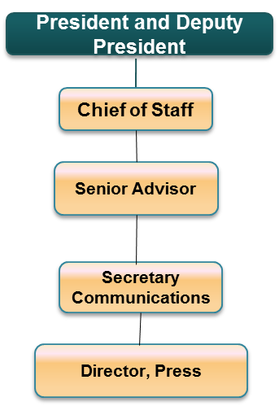

The Director Press will deputise the Secretary Communications.

Specific duties will include:

1. The Director will be in charge of the internal Press (Presidential Press Service)
2. Develop a communication strategy for the Executive Office of the Presidency and Office of the First Lady;
3. Ensure that Print, Television, Radio and Technical section of the Press service work seamlessly to communicate the Presidency;
4. Ensure succession planning as well as training development of personnel;
5. Develop content for different medium including social media;
6. Conceptualize the broad framework of points or messages, research on topics and blend points, themes, positions, and messages with own research to create messaging for the Presidency and the Office of the First Lady;
7. Ensure that the administration's message is delivered successfully;
8. Support the Presidency’s media outreach activities;
9. Support the establishment of unit/departmental goals and objectives;
10. Support in establishing resources and budget for the Communication Office at the EOP;
11. Manage responsibilities assigned within the Communications Office;
12. Support the Senior Advisor in articulating communication strategy direction;
13. Deputize the Secretary Communication in reviewing and reporting on Office’s progress as required;
14. Responsible for performance management tasks for the officers directly reporting to him/her;
15. Develop annual work-plans and performance standards for the Communications Office;

**Requirements for Appointment**

For appointment to this grade, an officer must have:

1. Requisite experience in any of the following: Communication, Communication Studies, Public Relations, Journalism, International Relations or Social Sciences;
2. In addition they must have at least 5 years of experience in the Communinication Industry;
3. Shown exemplary leadership qualities;
4. Shown outstanding capabilities in communications;
5. Be of high integrity, commitment to and demonstration of, ethical practices;
6. A proven ability to create standards for ethical behavior;
7. Ability to think analytically, within difficult constrains and develop solutions to problems;
8. Committed to excellence;
9. Ability to interact with peers and senior officials in a professional manner;

**Personal Qualities**

In addition to the above requirements, an officer must have the following qualities;

* High commitment and ability to set priorities;
* Ability to work with and manage virtual and flexible teams;
* Organizational, conceptual and analytical, managerial and decisive skills;
* Creativity, dynamism and innovation;
* Resource management skills;
* Interpersonal and communication skills;
* Integrity and commitment to producing results;
* Leadership, advocacy, relationship building and collaboration;
* Self-drive and initiative to achieve expected results.

**Core Skills**

* People management
* Financial management
* Policy formulation and implementation
* Planning
* Organizing
* Directing
* Controlling
* Coordinating
* Strategy formulation

**Deputy Director - Editorial Content** - **JOB GROUP R**

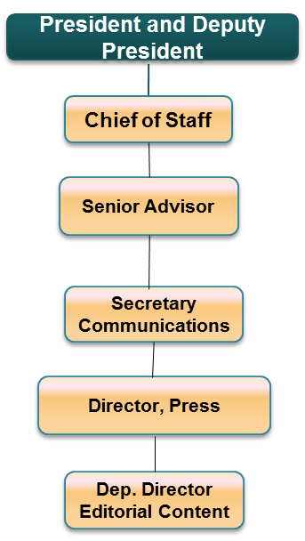

The Deputy Director – Editorial Content will deputise the Director Press

Specific duties will include:

1. Oversee news operations as the editorial head;
2. Initiate and review communications policy and design of appropriate programmes and infrastructure to facilitate implementation;
3. Review of packaged news products to ensure they conform with set news standards before they are disseminated to media and the public;
4. Ensure that deadlines are met;
5. Prepare media supplements, documentaries, press releases and media features;
6. Assign responsibilities to officers in the division;
7. Planning managing the assignment schedule;
8. Develop proposals for communication strategy;
9. Proactively manage risks and issues – escalate to the Director, Communications Secretary and Senior Advisor Communication as required;
10. Provide input into annual planning and forecasting;
11. Responsible for performance management tasks for both themselves and the officers directly reporting to them.

**Requirements for Appointment**

For appointment to this grade, an officer must have:

1. Requisite experience in any of the following: Communication, Communication Studies, Public Relations, Journalism, International Relations or Social Sciences;
2. In addition they must have at least 5 years of experience in the Communinication Industry;
3. Shown exemplary leadership qualities;
4. Shown outstanding capabilities in communications;
5. Be of high integrity, commitment to and demonstration of, ethical practices. A proven ability to create standards for ethical behavior;
6. Ability to think analytically, within difficult constrains and develop solutions to problems;
7. Committed to excellence;
8. Possess strong leadership skills required at that level;
9. Possess good oral and written communication skills in both English and Kiswahili; and
10. Ability to interact with peers and senior officials in a professional manner;

**Personal Qualities**

In addition to the above requirements, an officer must have the following qualities;

* High commitment and ability to set priorities;
* Ability to work with and manage virtual and flexible teams;
* Organizational, conceptual and analytical, managerial and decisive skills;
* Creativity, dynamism and innovation;
* Resource management skills;
* Interpersonal and communication skills;
* Integrity and commitment to producing results;
* Leadership, advocacy, relationship building and collaboration;
* Self-drive and initiative to achieve expected results.

**Deputy Director - First Lady’s Media Office** - **JOB GROUP R**

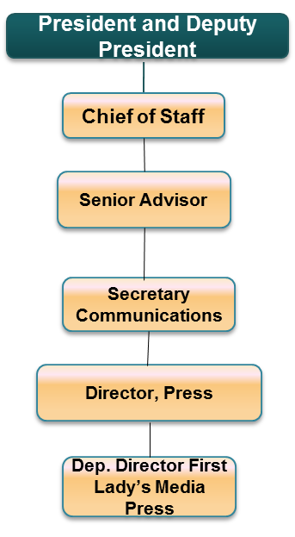The Deputy Director – First Lady’s Media Office will deputise the Director Press

Specific duties will include:

1. Develop a communication strategy for the Office of the First Lady;
2. Ensure that Print, Television, Radio and Technical section of the Press service work seamlessly to communicate the First Lady;
3. Develop First Lady’s media content for dissemination to external media and public;
4. Conceptualize the broad framework of points or messages, research on topics and blend points, themes, positions, and messages with own research to create messaging for the Office of the First Lady;
5. Support the First Lady’s media outreach activities;
6. Support the establishment of unit/departmental goals and objectives;
7. Support in establishing resources and budget for the Office of the First Lady;
8. Manage responsibilities assigned within the First Lady’s Communications Office;
9. Support the Director Press in articulating communication strategy direction;
10. Deputize the Director Press in reviewing and reporting on Office’s progress as required;
11. Planning and managing the First Lady’s communication assignment schedule;
12. Provide input into annual planning and forecasting;
13. Responsible for performance management tasks for both themselves and the officers directly reporting to them.

**Requirements for Appointment**

For appointment to this grade, an officer must have:

1. Requisite experience in any of the following: Communication, Communication Studies, Public Relations, Journalism, International Relations or Social Sciences;
2. In addition they must have at least 5 years of experience in the Communinication Industry;
3. Shown exemplary leadership qualities;
4. Shown outstanding capabilities in communications;
5. Be of high integrity, commitment to and demonstration of, ethical practices. A proven ability to create standards for ethical behavior;
6. Ability to think analytically, within difficult constrains and develop solutions to problems;
7. Committed to excellence;
8. Possess strong leadership skills required at that level;
9. Possess good oral and written communication skills in both English and Kiswahili; and
10. Ability to interact with peers and senior officials in a professional manner;

**Personal Qualities**

In addition to the above requirements, an officer must have the following qualities;

* High commitment and ability to set priorities;
* Ability to work with and manage virtual and flexible teams;
* Organizational, conceptual and analytical, managerial and decisive skills;
* Creativity, dynamism and innovation;
* Resource management skills;
* Interpersonal and communication skills;
* Integrity and commitment to producing results;
* Leadership, advocacy, relationship building and collaboration;
* Self-drive and initiative to achieve expected results.

**Deputy Director - Departmental Liaison** - **JOB GROUP R**

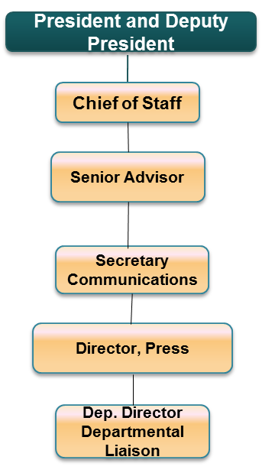

The Deputy Director –Departmental Liaison will deputise the Director Press

Specific duties will include:

1. Ensuring communication and cooperation between the communications department and other departments within State House and EOP;
2. Represent Communication department in State House departmental meetings;
3. Ensure that the administration's message is delivered successfully;
4. Provides executive level administrative support to the Secretary Communications and Director Press;
5. Works as a special liaison between the Secretary Communication and all employees, salaried and contracted to enhance direct communication between the Senior Leadership Team and employees.
6. Support the Presidency’s media outreach activities;
7. Support the establishment of unit/departmental goals and objectives;
8. Support in establishing resources and budget for the Communication Office at the EOP;
9. Manage responsibilities assigned within the Communications Office;
10. Support the Senior Advisor in articulating communication strategy direction;
11. Deputize the Secretary Communication in reviewing and reporting on Office’s progress as required;
12. Responsible for performance management tasks for the officers directly reporting to him/her;
13. Provide input into annual planning and forecasting;

**Requirements for Appointment**

For appointment to this grade, an officer must have:

1. Requisite experience in any of the following: Communication, Communication Studies, Public Relations, Journalism, International Relations or Social Sciences;
2. In addition they must have at least 5 years of experience in the Communinication Industry;
3. Shown exemplary leadership qualities;
4. Shown outstanding capabilities in communications;
5. Be of high integrity, commitment to and demonstration of, ethical practices. A proven ability to create standards for ethical behavior;
6. Ability to think analytically, within difficult constrains and develop solutions to problems;
7. Committed to excellence;
8. Possess strong leadership skills required at that level;
9. Possess good oral and written communication skills in both English and Kiswahili; and
10. Ability to interact with peers and senior officials in a professional manner;

**Personal Qualities**

In addition to the above requirements, an officer must have the following qualities;

* High commitment and ability to set priorities;
* Ability to work with and manage virtual and flexible teams;
* Organizational, conceptual and analytical, managerial and decisive skills;
* Creativity, dynamism and innovation;
* Resource management skills;
* Interpersonal and communication skills;
* Integrity and commitment to producing results;
* Leadership, advocacy, relationship building and collaboration;
* Self-drive and initiative to achieve expected results.

**Director Digital Strategy & Diaspora Relations: - JOB GROUP S**

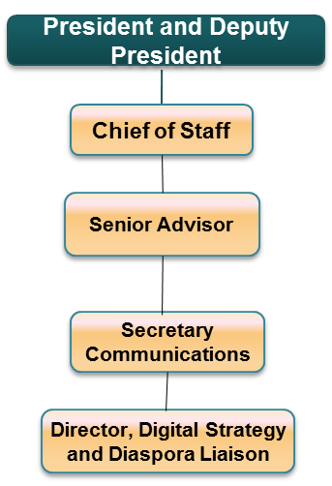The Director Digital Strategy will deputise the Secretary Communications.

Specific duties will include:

1. Develop the Digital Strategy for the Presidency;
2. Deliver and receive digital Government information and services anytime, anywhere and on any device safely and securely;
3. Enhance innovation that leverage Government data to improve services rendered by the Presidency;
4. Provide platforms for members of the public to connect with the Presidency;
5. Modernize content publication model to deliver digital services;
6. Developing online content for State House’s websites, blogs, mobile apps, short message services (SMS) program, email program;
7. Ensure there is official social media presence for the President;
8. Oversee the weekly social media address by the President;
9. Manage the Brand image of the Presidency;
10. Prepare set up for the weekly press corps briefing by the Communication Secretary;
11. Advice the Presidency on ways the Government can adjust to new digital world;
12. Liaising with Diaspora to allow constant interaction and exchange of ideas between the Presidency and the Diaspora;
13. Outline structures for diaspora engagement with the Presidency;
14. Mobilize the diaspora to act as partners in the development of Kenya;
15. Design policies and implement programs fundamental to diaspora relations;
16. Support the Presidency’s media outreach activities to include diaspora;
17. Support the establishment of unit/departmental goals and objectives;
18. Support in establishing resources and budget for the Communication Office at the EOP;
19. Manage responsibilities assigned within the Communications Office;
20. Support the Senior Advisor in articulating communication strategy direction;
21. Deputize the Secretary Communication in reviewing and reporting on Office’s progress as required;
22. Responsible for performance management tasks for the officers directly reporting to him/her;
23. Develop annual work-plans and performance standards for the Communications Office;

**Requirements for Appointment**

For appointment to this grade, an officer must have:

1. Requisite experience in any of the following: Communication, Communication Studies, Public Relations, Journalism, International Relations or Social Sciences;
2. In addition they must have at least 5 years of experience in the Communinication Industry;
3. Shown exemplary leadership qualities;
4. Shown outstanding capabilities in communications;
5. Be of high integrity, commitment to and demonstration of, ethical practices;
6. A proven ability to create standards for ethical behavior;
7. Ability to think analytically, within difficult constrains and develop solutions to problems;
8. Committed to excellence;
9. Ability to interact with peers and senior officials in a professional manner;

**Personal Qualities**

In addition to the above requirements, an officer must have the following qualities;

* High commitment and ability to set priorities;
* Ability to work with and manage virtual and flexible teams;
* Organizational, conceptual and analytical, managerial and decisive skills;
* Creativity, dynamism and innovation;
* Resource management skills;
* Interpersonal and communication skills;
* Integrity and commitment to producing results;
* Leadership, advocacy, relationship building and collaboration;
* Self-drive and initiative to achieve expected results.

**Core Skills**

* People management
* Financial management
* Policy formulation and implementation
* Planning
* Organizing
* Directing
* Controlling
* Coordinating
* Strategy formulation

**Deputy Director Digital Office: - JOB GROUP R**

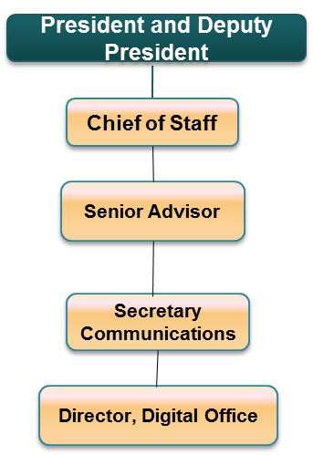The Deputy Director Digital Office will deputise the Director Digital Strategy

Specific duties will include:

1. Develop a social media strategy for the President, First Lady and State House to increase visibility, membership and traffic across platforms;
2. Develop online content and manage content for all Presidential and State House social media platforms including but not limited to Facebook, Twitter, Youtube, State House blog, Linkedin, Scribd and public online forums;
3. Provide timely and accurate information about the President's latest events and public statements while including photos, video, and transcripts, as well as proclamations, executive orders, and press releases;
4. Prepare social media analytics;
5. Ensure shared platform approach to developing and delivering digital services and managing data;
6. Assign responsibilities to officers in the division;
7. Planning managing the assignment schedule;
8. Develop proposals for communication strategy;
9. Proactively manage risks and issues – escalate to the Director, Communications Secretary and Senior Advisor Communication as required;
10. Provide input into annual planning and forecasting;
11. Responsible for performance management tasks for both themselves and the officers directly reporting to them.

**Requirements for Appointment**

For appointment to this grade, an officer must have:

1. Requisite experience in any of the following: Communication, Communication Studies, Public Relations, Journalism, International Relations or Social Sciences;
2. In addition they must have at least 5 years of experience in the Communinication Industry;
3. Shown exemplary leadership qualities;
4. Shown outstanding capabilities in communications;
5. Be of high integrity, commitment to and demonstration of, ethical practices. A proven ability to create standards for ethical behavior;
6. Ability to think analytically, within difficult constrains and develop solutions to problems;
7. Committed to excellence;
8. Possess strong leadership skills required at that level;
9. Possess good oral and written communication skills in both English and Kiswahili; and
10. Ability to interact with peers and senior officials in a professional manner;

**Personal Qualities**

In addition to the above requirements, an officer must have the following qualities;

* High commitment and ability to set priorities;
* Ability to work with and manage virtual and flexible teams;
* Organizational, conceptual and analytical, managerial and decisive skills;
* Creativity, dynamism and innovation;
* Resource management skills;
* Interpersonal and communication skills;
* Integrity and commitment to producing results;
* Leadership, advocacy, relationship building and collaboration;
* Self-drive and initiative to achieve expected results.

**Deputy Director New & Direct Media & Diaspora Relations:- JOB GROUP R**

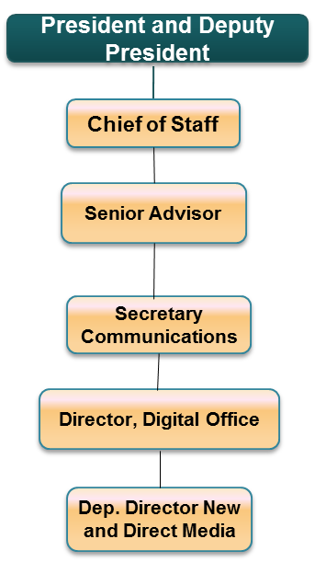

The Deputy Director New and Direct Media will deputise the Director Digital Strategy.

Specific duties will include:

1. Ensure development and creation of content for the State House’s websites, mobile apps and short message services (SMS);
2. Develop Application Programming Interfaces (API’s);
3. Research and advice on ways the EOP can adopt light technologies such as cloud computing, shared services and modular approaches for IT development;
4. Provide guidance and recommendations on building a digital government within EOP;
5. Utilize new media and emerging media options to communicate the Presidency;
6. Link local, foreign media and the public with feeds from mediums such as podcasts and RSS (Rich Site Summary);
7. Ensure on-demand access to content any time, anywhere, on any digital device, interactive user feedback and creative participation of the public;
8. Explore solutions for future government digital services;
9. Optimize content for modern platforms to ensure the public can access content from the EOP;
10. Design concepts and refresh content delivery mechanisms to ensure highest performance within the EOP;
11. Develop channels for Diaspora Communications within EOP;
12. Strengthening and inventory of existing diaspora institutions and program;
13. Attend planning meetings and make presentations to staff and EOP to decide the strategic and creative direction of campaigns and events;
14. Assign responsibilities to officers in the division;
15. Planning managing the assignment schedule;
16. Develop proposals for communication strategy;
17. Proactively manage risks and issues – escalate to the Director, Communications Secretary and Senior Advisor Communication as required;
18. Provide input into annual planning and forecasting;
19. Responsible for performance management tasks for both themselves and the officers directly reporting to them.

**Requirements for Appointment**

For appointment to this grade, an officer must have:

1. Requisite experience in any of the following: Communication, Communication Studies, Public Relations, Journalism, International Relations or Social Sciences;
2. In addition they must have at least 5 years of experience in the Communication Industry;
3. Shown exemplary leadership qualities;
4. Shown outstanding capabilities in communications;
5. Be of high integrity, commitment to and demonstration of, ethical practices. A proven ability to create standards for ethical behavior;
6. Ability to think analytically, within difficult constrains and develop solutions to problems;
7. Committed to excellence;
8. Possess strong leadership skills required at that level;
9. Possess good oral and written communication skills in both English and Kiswahili; and
10. Ability to interact with peers and senior officials in a professional manner;

**Personal Qualities**

In addition to the above requirements, an officer must have the following qualities;

* High commitment and ability to set priorities;
* Ability to work with and manage virtual and flexible teams;
* Organizational, conceptual and analytical, managerial and decisive skills;
* Creativity, dynamism and innovation;
* Resource management skills;
* Interpersonal and communication skills;
* Integrity and commitment to producing results;
* Leadership, advocacy, relationship building and collaboration;
* Self-drive and initiative to achieve expected results.

**Director Brand Strategy and Events Management:- JOB GROUP S**

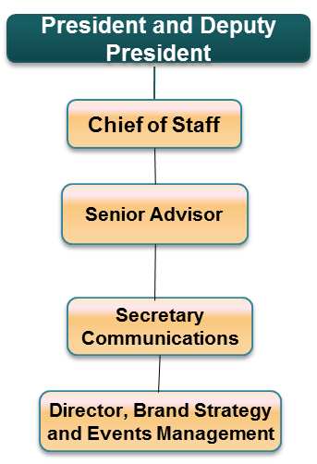The Deputy Director Events and Branding will deputise the Director Digital Strategy

Specific duties will include:

1. Being responsible for the production of events and programs from conception through to completion;
2. Develop creative programs and design concepts that meet the objectives of the EOP and that advance brand strategy of the Presidency;
3. Researching markets and client liaison to ascertain the precise Presidential event and Presidential brand requirements;
4. Proposal writing;
5. Lead creative sessions for project kick-offs as well as managing projects;
6. Coordinating suppliers, budget making and producing detailed timelines;
7. Commissioning specialists, such as artists and photographers, to work on projects;
8. Coordinating all TV and Radio and Online Presidential productions;
9. Compile the brand manual for the Presidency, Office of the First Lady and State House and establish the creative direction;
10. Interact with other departments to maintain communication and satisfaction of the EOP and the Public;
11. Attend planning meetings and make presentations to staff and EOP to decide the strategic and creative direction of campaigns and events;
12. Oversee aspects of Presidential Publication like layout and graphic designs;
13. Assign responsibilities to officers in the division;
14. Planning managing the assignment schedule;
15. Develop proposals for communication strategy;
16. Proactively manage risks and issues – escalate to the Director, Communications Secretary and Senior Advisor Communication as required;
17. Provide input into annual planning and forecasting;
18. Responsible for performance management tasks for both themselves and the officers directly reporting to them.

**Requirements for Appointment**

For appointment to this grade, an officer must have:

1. Requisite experience in any of the following: Communication, Communication Studies, Public Relations, Journalism, International Relations or Social Sciences;
2. In addition they must have at least 5 years of experience in the Communication Industry;
3. Shown exemplary leadership qualities;
4. Shown outstanding capabilities in communications;
5. Be of high integrity, commitment to and demonstration of, ethical practices. A proven ability to create standards for ethical behavior;
6. Ability to think analytically, within difficult constrains and develop solutions to problems;
7. Committed to excellence;
8. Possess strong leadership skills required at that level;
9. Possess good oral and written communication skills in both English and Kiswahili; and
10. Ability to interact with peers and senior officials in a professional manner;

**Personal Qualities**

In addition to the above requirements, an officer must have the following qualities;

* High commitment and ability to set priorities;
* Ability to work with and manage virtual and flexible teams;
* Organizational, conceptual and analytical, managerial and decisive skills;
* Creativity, dynamism and innovation;
* Resource management skills;
* Interpersonal and communication skills;
* Integrity and commitment to producing results;
* Leadership, advocacy, relationship building and collaboration;
* Self-drive and initiative to achieve expected results.

**Deputy Director Master of Ceremonies:- JOB GROUP R**

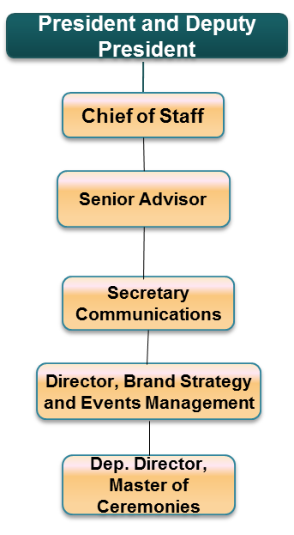The Deputy Director Master of Ceremony will deputise the Director Digital Strategy.

Specific duties will include:

1. Serving as a genial host in Presidential functions;
2. Being responsible for ensuring that the program/event runs smoothly;
3. Ensuring that Presidential programs runs on time;
4. Ensuring that important people at the event are introduced in a complimentary, professional manner;
5. Present performers, speaks to the audience, and generally keep all Presidential events moving;
6. Attend planning meetings and make presentations to staff and EOP to decide the strategic and creative direction of campaigns and events;
7. Oversee aspects of Presidential Publication like layout and graphic designs;
8. Assign responsibilities to officers in the division;
9. Planning managing the assignment schedule;
10. Develop proposals for communication strategy;
11. Proactively manage risks and issues – escalate to the Director, Communications Secretary and Senior Advisor Communication as required;
12. Provide input into annual planning and forecasting;
13. Responsible for performance management tasks for both themselves and the officers directly reporting to them.

**Requirements for Appointment**

For appointment to this grade, an officer must have:

1. Requisite experience in any of the following: Communication, Communication Studies, Public Relations, Journalism, International Relations or Social Sciences;
2. In addition they must have at least 5 years of experience in the Communinication Industry;
3. Shown exemplary leadership qualities;
4. Shown outstanding capabilities in communications;
5. Be of high integrity, commitment to and demonstration of, ethical practices. A proven ability to create standards for ethical behavior;
6. Ability to think analytically, within difficult constrains and develop solutions to problems;
7. Committed to excellence;
8. Possess strong leadership skills required at that level;
9. Possess good oral and written communication skills in both English and Kiswahili; and
10. Ability to interact with peers and senior officials in a professional manner;

**Personal Qualities**

In addition to the above requirements, an officer must have the following qualities;

* High commitment and ability to set priorities;
* A person who has poise, presence and who can command the attention of an audience;
* Ability to work with and manage virtual and flexible teams;
* Organizational, conceptual and analytical, managerial and decisive skills;
* Creativity, dynamism and innovation;
* Resource management skills;
* Interpersonal and communication skills;
* Integrity and commitment to producing results;
* Leadership, advocacy, relationship building and collaboration;
* Self-drive and initiative to achieve expected results.

**OFFICE OF THE FIRST LADY**

The First Lady will serve as the State House hostess. She will support and attends official ceremonies and functions of state either along with the president or in her capacity as First Lady. The First Lady will manage the household affairs of State Houses and Lodges. She will oversee renovations to the residence, as well as seasonal decorations and preparations for important visitors and events held on-site. The First Lady will also advocate for issues of personal interest and act as patron to key initiatives of her choice.

The Office of the First Lady will be supported by a core team of professional staff and advisors.

**Chief of Staff Office of the First Lady – JOB GROUP U**

The Office of the Chief of Staff is responsible for directing, managing, planning and overseeing daily operations and staff activities of The First Lady

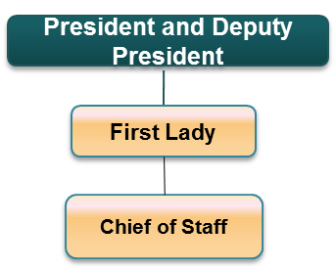

This position plays both a managerial and advisory role that encompasses several important functions as follows:

* Providing guidance in implementing the First Lady’s Agenda
* Selecting and supervising key staff and departments within State House
* Structuring the First Lady’s office and staff system
* Protecting the interests of the First Lady
* Controlling access to the First Lady
* Managing communication and information flow
* Advising the First Lady on various issues
* Assisting the First Lady in implementing her agenda
* Assigning/delegating responsibilities within the office
* Articulating the President’s policy and strategic focus to stakeholders and to the general public
* Liaising with Senior Advisors to the President and the President’s and Deputy President’s respective Chiefs of Staff (when necessary) in the implementation of their mandates
* Liaising with the Office of the Comptroller
* Proactively manage risks and issues and escalate these to the First Lady if required
* Provide input into the First Lady’s and Presidency’s (where necessary) annual planning and forecasting
* Oversee the Performance Management processes for the Office of the First Lady
* Act as a central contact point for all areas within the First Lady’s office
* Oversee the definition, implementation and continuous improvement of policies and procedures to deliver on the First Lady’s agenda
* Represent the First Lady at any meeting if required

**Requirements for the appointment:**

1. Masters Degree (further qualifications are an added advantage)
2. Demonstrate outstanding professional and managerial competence in a previous position/s
3. Be of high integrity and show commitment to ethical practices
4. Maintain confidentiality
5. Ability to think strategically and analytically
6. Ability to solve problems and resolve issues especially under stressful conditions
7. High performance energy and commitment to excellence
8. Ability to inspire confidence in others and draw out best performance from the team
9. Exemplary leadership qualities
10. Demonstrate a clear understanding of constitutionalism (specifically the Presidency), law, national development policies, goals and objectives
11. Set performance management standards in all areas of the office

**Personal Qualities**

* Self-starter with high commitment and ability to set priorities;
* Ability to work with and manage virtual and flexible teams;
* Organizational, conceptual and analytical, managerial and decisive skills;
* Creativity, dynamism and innovation;
* Resource management skills;
* Interpersonal and communication skills;
* Integrity and commitment to producing results;
* Leadership, advocacy, relationship building and collaboration;
* Self-drive and initiative to achieve expected results.

**Core Skills**

* People management
* Financial management
* Planning
* Organizing
* Directing
* Controlling
* Coordinating
* Strategy formulation

**Environment Project Director - JOB GROUP T**

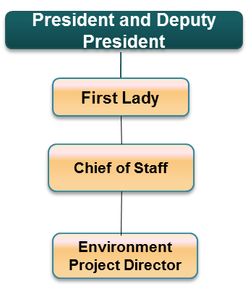Reporting through the Chief of Staff, the Director will have the overall management role of the specified project

**Specific duties will include:**

1. The Director will be in charge of the Environmental Project
2. Develop a development and communication strategy for the Project;
3. Recruit and train personnel in support of the project;
4. Develop project content for different medium including social media;
5. Support the First Lady’s outreach activities;
6. Support the establishment of project performance goals and objectives;
7. Establish and manage resources and budget for the project;
8. Responsible for performance management and development of KPI’s of the project staff directly reporting to him/her;
9. Submit periodic reports and feedback on project progress;

**Requirements for Appointment**

For appointment to this grade, an officer must:

1. Hold a Bachelor’s degree in the project related discipline from a recognized institution;
2. Show exemplary leadership qualities;
3. Show outstanding capabilities in project management in their respective area of specialization;
4. Be of high integrity with commitment to and demonstration of, ethical practices;
5. A proven ability to create standards for ethical behavior;
6. Ability to think analytically, within difficult constrains and develop solutions to problems;
7. Committed to excellence;
8. Ability to interact with peers and senior officials in a professional manner;

**Personal Qualities**

In addition to the above requirements, an officer must have the following qualities;

* High commitment and ability to set priorities;
* Ability to work with and manage virtual and flexible teams;
* Organizational, conceptual and analytical, managerial and decisive skills;
* Creativity, dynamism and innovation;
* Resource management skills;
* Interpersonal and communication skills;
* Integrity and commitment to producing results;
* Leadership, advocacy, relationship building and collaboration;
* Self-drive and initiative to achieve expected results.

**Core Skills**

* People management
* Financial management
* Planning
* Organizing
* Directing
* Controlling
* Coordinating
* Strategy formulation

**Gender Project Director - JOB GROUP T**

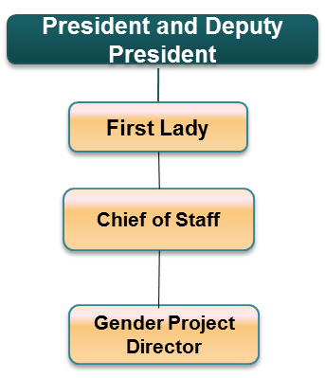Reporting through the Chief of Staff, the Director will have the overall management role of the Gender Project

Specific duties will include:

1. The Director will be in charge of the specific Gender Project
2. Develop a development and communication strategy for the Project;
3. Recruit and train personnel in support of the project;
4. Develop project content for different medium including social media;
5. Support the First Lady’s outreach activities;
6. Support the establishment of project performance goals and objectives;
7. Establish and manage resources and budget for the project;
8. Responsible for performance management and development of KPI’s of the project staff directly reporting to him/her;
9. Submit periodic reports and feedback on project progress;

**Requirements for Appointment**

For appointment to this grade, an officer must:

1. Hold a Bachelor’s degree in the project related discipline from a recognized institution;
2. Show exemplary leadership qualities;
3. Show outstanding capabilities in project management in their respective area of specialization;
4. Be of high integrity with commitment to and demonstration of, ethical practices;
5. A proven ability to create standards for ethical behavior;
6. Ability to think analytically, within difficult constrains and develop solutions to problems;
7. Committed to excellence;
8. Ability to interact with peers and senior officials in a professional manner;

**Personal Qualities**

In addition to the above requirements, an officer must have the following qualities;

* High commitment and ability to set priorities;
* Ability to work with and manage virtual and flexible teams;
* Organizational, conceptual and analytical, managerial and decisive skills;
* Creativity, dynamism and innovation;
* Resource management skills;
* Interpersonal and communication skills;
* Integrity and commitment to producing results;
* Leadership, advocacy, relationship building and collaboration;
* Self-drive and initiative to achieve expected results.

**Core Skills**

* People management
* Financial management
* Planning
* Organizing
* Directing
* Controlling
* Coordinating
* Strategy formulation

**Education Project Director - JOB GROUP T**

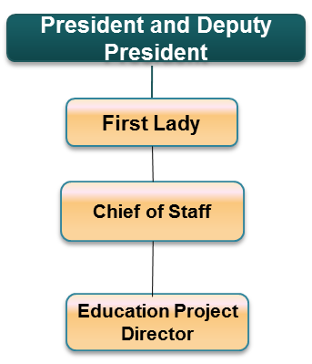Reporting through the Chief of Staff, the Director will have the overall management role of the Education Project

Specific duties will include:

1. The Director will be in charge of the specific Education Project
2. Develop a development and communication strategy for the Project;
3. Recruit and train personnel in support of the project;
4. Develop project content for different medium including social media;
5. Support the First Lady’s outreach activities;
6. Support the establishment of project performance goals and objectives;
7. Establish and manage resources and budget for the project;
8. Responsible for performance management and development of KPI’s of the project staff directly reporting to him/her;
9. Submit periodic reports and feedback on project progress;

**Requirements for Appointment**

For appointment to this grade, an officer must:

1. Hold a Bachelor’s degree in the project related discipline from a recognized institution;
2. Show exemplary leadership qualities;
3. Show outstanding capabilities in project management in their respective area of specialization;
4. Be of high integrity with commitment to and demonstration of, ethical practices;
5. A proven ability to create standards for ethical behavior;
6. Ability to think analytically, within difficult constrains and develop solutions to problems;
7. Committed to excellence;
8. Ability to interact with peers and senior officials in a professional manner;

**Personal Qualities**

In addition to the above requirements, an officer must have the following qualities;

* High commitment and ability to set priorities;
* Ability to work with and manage virtual and flexible teams;
* Organizational, conceptual and analytical, managerial and decisive skills;
* Creativity, dynamism and innovation;
* Resource management skills;
* Interpersonal and communication skills;
* Integrity and commitment to producing results;
* Leadership, advocacy, relationship building and collaboration;
* Self-drive and initiative to achieve expected results.

**Core Skills**

* People management
* Financial management
* Planning
* Organizing
* Directing
* Controlling
* Coordinating
* Strategy formulation

**Senior Administrator/Assistant Director - First Lady’s Office** - **JOB GROUP Q**

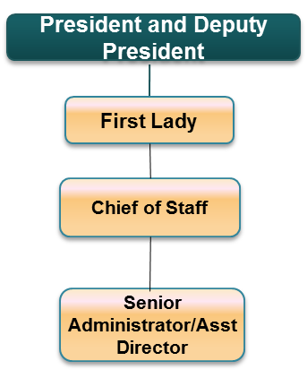Reporting through the Chief of Staff, this position will provide overalladministrative support to the Office of the First Lady.

**Specific duties will include:**

1. General Office Management and Housekeeping
2. Hospitality and Event Co-ordination
3. Liaison with Protocol office (for local and foreign travel) and logistics
4. Scheduling of meetings (internal and external) and management of calendar
5. Handling of mail and correspondence (internal and external)
6. Management of Office budget
7. Responsible for performance of tasks for subordinate staff allocated to the Office of the First Lady
8. Co-ordination with officers in the Comptroller’s office to ensure efficient and effective provision of administrative services within State House and other State lodges as required
9. Any other duties allocated as and when necessary

**Requirements for Appointment**

For appointment to this grade, an officer must:

1. Hold a Bachelor’s degree;
2. Show exemplary organization and co-ordination qualities in a similar position;
3. Show good communication skills (fluency in a second language is essential) ;
4. Be of high integrity and be able to maintain confidentiality;
5. Have ability to think with clarity under difficult conditions and to develop requisite solutions;
6. Be committed to excellence and be focused on delivering results;
7. Possess good oral and written communication skills in English , Kiswahili and one other language (e.g. French, Spanish or Portuguese); and
8. Have the ability to interact with peers and senior officials in a professional and diplomatic manner;

**Personal Qualities**

In addition to the above requirements, an officer must have the following qualities;

* High commitment and ability to set priorities;
* Ability to work with virtual and flexible teams;
* Organizational, conceptual and analytical skills;
* Creativity, dynamism and innovation;
* Resource management skills;
* Interpersonal and communication skills;
* Integrity and commitment to producing results;
* Leadership, advocacy, relationship building and collaboration;
* Takes ownership for promoting and protecting the Office:
* Self-drive and initiative to achieve expected results.

08

**Fall**

**PROPOSED STRUCTURE OF THE EXECUTIVE OFFICE OF THE DEPUTY PRESIDENT**

1. **INTRODUCTION**

The presidency is comprised of the Office of the President and the office of the deputy president. In structuring the presidency, the president has created Executive Office of the President and the Executive offices of the deputy president to enable them perform their executive functions. The new presidency is the titular head of the national executive and includes and enhances the functions normally done by state house, office of the president and some of the functions hitherto undertaken by the abolished offices of the prime minister and the vice president. Further, the president has in his new structure of the national executive created two ministries to operate out of the presidency. Ministry of interior and Coordination of National Government and ministry of devolution & planning.

**EXECUTIVE OFFICE OF THE DEPUTY PRESIDENT**

1. **LEGAL BASIS**

The Office of the Deputy President is organized in accordance with Chapter 9 of the Constitution on the structure of the National Executive and pursuant to the mandate of the Deputy President under Article 147 of the Constitution.

1. **MANDATE**

The mandate of the Deputy President as defined by Article 147 of the Constitution is:

1. The Deputy President shall be the principal assistant of the President and shall deputise for the President in the execution of the President’s functions.
2. The Deputy President shall perform the functions conferred by this Constitution and any other functions of the President as the President may assign.
3. Subject to Article 134, when the President is absent or is temporarily incapacitated, and during any other period that the President decides, the Deputy President shall act as the President.
4. The Deputy President shall not hold any other State or public office.
5. **FUNCTION**

The assigned functions to the deputy president will be:

* To chair all the Cabinet Committees except the committee on Security
* Deputise for the president in directing and coordinating the functions of ministries and government departments.
* Deputise for the president on government and state functions

1. **EXECUTIVE OFFICE OF THE DEPUTY PRESIDENT (EODP)**

The functions of the Executive Office of the Deputy President are to provide the necessary technical and support services to the Deputy President to enable him to perform his mandate efficientlyand effectively.

***The functions in the EODP classified into:***

1. Executive function
2. Ceremonial function
3. Advisory function
4. Cabinet function
5. Administrative function

Most of the functions will be shared with the executive office of the president in the presidency.

**Mapping of Functions of the EODP against Structural Form**

|  |  |
| --- | --- |
| **Description of Function** | **Functional Units** |
| 1. **Executive Function** | |
| * **The Deputy President will deputise the President to direct, coordinate and supervise the execution of the functions and affairs of ministries and government departments.** | **Office of the Chief of Staff**   1. **Policy Coordination Unit:** Coordination of Cabinet Committee Meetings, Research and Technical Advisory services to the Deputy President 2. **Strategy & Delivery Unit:** Relentless implementation of Presidential Priorities 3. **Communication Unit:** Strategic Communications for the Deputy President and his Office 4. **National Strategic Initiatives Unit**    * LAPPSET Authority |
| 1. **Ceremonial Function** | |
| * **The Deputy President performs ceremonial functions through meetings with representatives of foreign governments. He represents the Kenyan government in official gatherings and receives foreign dignitaries, ambassadors, foreign investors, and other foreign officials. Though reporting to the principal Administrative secretary, the unit will liaise very closely with the office of the private secretary** | **Office of the Private Secretary**   1. **Diary Unit:** Coordination of the Deputy President’s Diary 2. **Protocol Unit:** Diplomatic Protocol and Foreign Travel Coordination 3. **Operations Unit:** State Protocol &Coordination of Operations and Logistics 4. **Hospitality Unit:** Official Residence and Spousal support |
| 1. **Advisory Function** | |
| * **As a member of the Cabinet, the Deputy President participates in the formulation of policies in the implementation of government programs and projects. The advisory team will be drawn from the Executive Office of the President.** | **Office of the Chief of Staff**   1. Governance & Constitution Advisor 2. Economic Affairs Advisor 3. Infrastructure Advisor 4. Political advisor 5. Constitutional & Legislative Affairs Advisor 6. Communications Advisor 7. Security Advisor |
| 1. **Cabinet Function** | |
| * **The Deputy President performs cabinet functions managing and running cabinet committees. The function sets agenda, conduct meetings and follow through. The function’s secretariat will be drawn from the shared structure of the presidency** | **Office of the Chief of Staff**   1. Secretary to Cabinet committees 2. Research Team 3. Legal |
| 1. **Administrative Function:** | |
| * **The Deputy President performs administrative functions to ensure that the resources of the EODP are efficiently used to attain the goals and objectives of the office** | **Principal Administrative Secretary**   1. **Administration**    * Finance    * Accounts    * HR    * Audit    * ICT    * Procurement    * Social Secretary    * Administrative support services |

Below is the structure of the Executive Office of the Deputy President

1. **UNIT FUNCTIONS, CAPABILITIES AND JOB DESCRIPTIONS**
   1. **Chief of Staff**

The Deputy President’s Chief of Staff is the Principal Assistant to the Deputy President of the Republic of Kenya. The Chief of Staff also oversees the Executive Office the Deputy President (EODP).

Within the Office of the Deputy President, the Chief of Staff is the Accounting and Authorized Officer and will oversee the implementation of all the planned activities of the Office. All the Officers and Departments/units in the Office of the Deputy President will report to the Chief of Staff.

Chief of Staff is responsible for overseeing the actions of the Deputy President's staff and managing the Deputy President’s schedule.

The position typically plays both a managerial and advisory role that encompasses several important functions:

* Select and supervise key staff
* Structure the office staff system
* Protect the interests of the Deputy President
* Control access to the Office and the Deputy President
* Manage communications and information flow
* Advise the Deputy President on various issues
* Assist the Deputy President implement the President’s agenda
* Liaise with the Senior Advisors/Assistants to the President, Chief of Staff of the EOP and the Statehouse comptroller in the implementation of their mandates.
* Proactively manage risks and issues and escalate to the Deputy President as required
* Provide input into Presidency’s annual planning and forecasting
* Oversee the performance management processes for the Deputy Presidents office.
* Act as central contact point for all areas within the Deputy Presidents office.
* Oversee the definition, implementation and continuous improvement of policies, processes and procedures that deliver on the Presidency’s agenda.

The Chief of Staff to the Deputy Presidency will carry out any other duties as may be assigned by the Presidency.

* 1. **Private Secretary**

The Deputy President’s Private Secretary will be responsible for coordination of political, ceremonial and executive matters of a personal nature in support of the Deputy President. In this context he will be personally responsible for the DP’s Diary, Protocol, Operations and Hospitality. The unit headed by a Social Secretary though reporting to the Principal Administrative secretary will coordinate with the private Secretary on the deputy president’s activities.

* 1. **Policy Coordination Unit**

The Deputy President deputizes the President in performing political, policy and administrative functions. This involves oversight over the performance of Cabinet Secretaries, supervising the execution of Government policy and providing leadership in setting the Cabinet and Legislative agenda of Government.

The creation of a specialized Policy unit, responsible for policy oversight for the delivery and of the Administration’s pledges. The unit will be responsible for advising and assisting the Presidency in the formulation, coordination and implementation of government policy. It will also provide support for other policy development and implementation activities as directed by the President. This unit will work together with the Strategy and Delivery Unit in ensuring that the identified policy priorities take off and are implemented and sustainable.

The Policy Coordination Department will carry out the following functions:

1. Provide policy and strategy advice to the Presidency to ensure that Government policies are aligned to an overall cohesive strategic direction
2. Support, prioritise and progress the policy and strategic initiatives of the Presidency
3. Research and undertake analysis of emerging issues of major policy concern
4. Advise the President on an effective stakeholder engagement and collaborate with the Ministries/Departments for this to be institutionalized
5. the development of a comprehensive Policy framework delivery matrix;
6. conceptualization, development of priority project policy underpinnings;
7. initiating policies and providing high-level supervision that would ensure time-bound creation delivering of Administration’s priorities matching international standards,
8. Liaison with Parliament and relevant and responsible government ministries and agencies;
9. Monitoring and reporting to the Presidency on the Administration’s pledges delivery; and

The Policy Coordination Department will promote innovation and excellence in policy development and analysis and will encourage collaboration between Government, non-state actors and international organizations. The Department will work with Ministries to ensure that all citizens have access to information on social, economic and environmental outcomes from Government policies and programs.

**Staffing**

The Policy Coordination Department will be headed by a Secretary who will be deputised by Directors and assisted by analysts as indicated in the staff establishment.

* 1. **Strategy & Delivery Unit**

The efficient, timely and cost effective implementation of the flagship projects as identified by the Administration is key to ensuring the transformative outcomes captured in our vision in addition to underwriting Kenya achieving the goals set out in Vision 2030. These projects centre on the, Employment creation, Health, Education, Agriculture and Infrastructure development sectors.

A Strategy & Delivery Unit has been created in the Presidency to be managed in the Executive Office of the Deputy President to supervise the implementation of both National and Administration’s Priorities and the key Ministerial Priorities including unblocking any obstacles that pose challenges to achieving intended outcomes.

Its main functions will be to:

1. Oversee and report progress on delivery of the Administration’s Priorities
2. Ensure that a lead Ministry is appointed where more than one is involved in meeting a priority target and that a senior responsible officer is appointed and agreed project management principles are followed
3. examining and recommending for approval/rejection/modification all nationally significant Administration’s priority projects across all sectors,
4. high-level supervision of all priority Administration’s projects to ensure that they are up to standard and within budget,
5. formulation of policies to encourage development of efficient, timely and cost effective delivery of priority Administration’s projects including applying public-private partnerships (PPPs) approaches,
6. receiving and seeking input from stakeholders such as local communities, environmental and safety agencies in the delivery the priority Administration’s projects and advising the Government on the same,
7. implementation of qualifying infrastructure projects, and
8. coordination of the activities of the various Government Agencies involved in infrastructure development.
9. Identify capacity gaps which inhibit delivery of priorities and refer them to the appropriate responsible unit of Government
10. Facilitate cross-Ministry coordination
11. Intervene to provide support where the Strategy & Delivery Unit has the required capability or facilitate support from a third party such as KIA/Kenya School of Government
12. Ensure that appropriate accountability and performance management mechanisms are in place to underpin successful implementation.

**Staffing**

The Unit will be headed by a Secretary who will be assisted by two Directors and other staff.

* 1. **Principle Administrative Secretary**

The Principal Administrative Secretary is the chief administrator in the Office of the Deputy President and will oversee the implementation of all the planned activities on behalf of the Chief of Staff. The position of Principal Administrative Secretary has been created at a job group equivalent to that of the Principal Secretary.

The Senior Officials under the PAS will be responsible for the strategic direction of their Departments as well as ensure that they contribute effectively to the objectives of the Office of the Deputy President as a whole. The following Departments will be under the direct supervision of the Principal Administrative Secretary:

1. Administration
2. Finance
3. HR
4. Audit
5. Social Secretary Unit
   * 1. **Administration**
6. Correspondences
7. Office services
8. ICT
9. HIV/AIDS control Unit
   * 1. **Finance**

The unit ensures that all Finance activities are done effectively to ensure compliance with the governments Finance policies, procedures and regulations. It has two units: Procurement and accounts

* 1. **Accounts**

The division subscribes to ensure interpretation of Financial Legislations, provision of timely and accurate financial reports based on professionalism, ethical values and Accountability

* 1. **Procurement**

The department handles procurement related matters

**Staffing**

The Administrative Support Services will be headed by a Director Administration reporting to the Principal Administrative Secretary

* + 1. **HR**

Human Resources procedures is to ensure that all Human Resources activities are done effectively to ensure compliance with the Government’s Human Resources management policies and procedures

* + 1. **Audit**

The division ensures the effective utilization of public funds and that laid down policies and procedures are followed.

* + 1. **Social Secretary**

The unit though reporting to the Principal Administrative Secretary will work closely with the Private Secretary in ensuring that the Deputy President’s events are planned and adequately executed.

The Social Secretary will plan events for the Deputy President and work with the EOP’s Social Secretary and ministry of Foreign Affairs to coordinate domestic and international visits. The office is also responsible for the production invitations to social events.

The Social Secretary will work on both the political and non-political functions of the presidency, coordinating events for the Deputy President and that of the office of Rachel Ruto. The functional responsibilities and staffing for the units under the Private Secretary are enumerated here below.

* + - 1. **Diary Unit**

The Deputy President’s Diary Management is a critical component of the Deputy President’s delivery agenda. This is because the Deputy President’s time needs to be managed in a manner that results in efficient delivery of his all his responsibilities. Apart from catering for official functions, the Diary of the Deputy President must avail time for him to address the needs of Kenyans and should enable him to connect with ordinary people.

The Diary Unit will therefore manage the Deputy President’s agenda in a timely and proactive manner. In addition to the office work that accompanies his mandate, the Deputy President will make regular travel to meet local leaders, monitor and inspect projects nationally, meet international leaders, and attend conferences as well as attending to party and coalition matters. It is, therefore imperative that in arranging the Diary, all these issues are contextualized in the order of their importance.

**Staffing**

The Unit will be headed by an Under Secretary, Diary Management and supported by two officers.

* + - 1. **Protocol Unit**

The Deputy President will on various occasions be called upon to represent the country in international fora and functions as well as represent the president in local functions. The Protocol Unit will be charged with ensuring proper coordination and facilitation of the Deputy President during all his foreign and local travel.

The Officers in this unit will have a clear understanding of international diplomatic affairs and protocol and establish close linkages with the Ministry of Foreign Affairs including Kenyan Missions abroad.

**Staffing**

The unit will be headed by a Head of protocol who will report to the Social Secretary.

* + - 1. **Operations Unit**

The Deputy President will attend official and political functions, conferences and banquets, opens workshops and other gatherings both across the country on behalf of the president. The Unit will ensure that these activities are well coordinated and that the Deputy President’s speeches are relevant to the occasion and relate to Government’s Vision and Mission.

Additionally, the unit is charged with ensuring that proper State protocols are observed as the Deputy President and his Office conduct Government Business both within the country. As such the Unit will organise official visits on behalf of the Deputy President and to offer protocol advice.

The Officers in this Unit will have a clear understanding of local and international affairs, with capabilities to analyse requirements and make rational choices. They must also be meticulous in planning and recording and will need to have excellent interpersonal skills. The Unit will work closely with the Diary Unit, Communications Unit, and the Administration Department.

The Unit will also develop and institutionalize the relevant structures and establish close linkages with other relevant government offices for a seamless working relationship with the protocol function of the Presidency.

**Staffing**

The Unit will be headed by a Director of Operations who will report to the Permanent Secretary.

* + - 1. **Hospitality Unit**

The Deputy President has official residence as well as his private residence. Within this context, the spouse of the Deputy President also performs both Government and private functions in the residences. The spouse receives official guests of the Government of Kenya and attends official functions on behalf of the Government and the Deputy President. She needs support on housekeeping/catering services, protocol and overall security of the residences.

**Staffing**

A staff establishment headed by a Head Hospitality and supported by a Programme Officer. The recruitment of these staff will be guided by the prevailing Government regulations released by the Public Service Commission from time to time. Clear job descriptions and specifications will be developed in order to have competent and qualified personnel to carry out the duties and responsibilities for the Administrative support office and the residences.

* 1. **National Strategic Initiatives unit**

In his responsibility in deputizing the President as the Coordinator and Supervisor of the affairs of government, the Deputy President will be responsible for coordination of government response to emerging issues of national concern and pursuing strategic government initiatives that are inter-ministerial in nature.

The National Strategic Initiative Unit will support the presidency in this role by putting in place mechanisms for effective coordination of government ministries and state departments and rapid response to emerging issues. The Department will oversee the following remit:

1. Lamu Port- Southern Sudan-Ethiopia Transport Authority (LAPSSET Authority)
2. Office of Task Forces and Coordination of Emerging Issues: To coordinate task forces established under the Office, Rapid Response to emerging National Issues

**Staffing**

The National Strategic Initiative function to be placed under the Strategy and Delivery Unit.

* 1. **Cabinet secretariat Unit**

In chairing the various Cabinet Committees, the Deputy President will require the secretariat service from the secretary to the cabinet.

The unit will administer Cabinet Committee business through:

1. Preparation and facilitation of cabinet committee meetings
2. Prepare cabinet committee memorandums on topical issues from respective ministries
3. Circulate Memoranda to the relevant ministries ahead of the meetings
4. Send out extract of action points as well as the minutes
5. Initial follow-up implementation of decisions made by the cabinet committee
6. Undertaking thorough research and consultations with the appropriate Ministries and the Departments/Units of government
7. Tracking and monitoring Government response to issues and questions that arise in Parliament and progress on the Government’s legislative initiatives.

**Staffing**

The Unit will be facilitated by the Secretary to Cabinet Secretary and report functionally to the Chief of Staff.

* 1. **Communications Unit**

*To insert content from OP*

* 1. **Senior Advisors**

The advisors in the presidency are structured under the executive office of the president but serve and report to both the president and the deputy president. The advisors will be non-Civil Service staff to provide expert advice to the presidency on wide ranging areas that will include: Governance and Constitutional Affairs, Economic Affairs and Infrastructure among others. Advisors will be recruited from time to time as need arise